11/26/2018

**2019 herring forecast for Togiak**

*Sara Miller and Sherri Dressel*

Forecasted biomass, age composition, and weight at age

The 2019 forecast for the Togiak herring stock is 217,548 tons (Figures 1–3; Table 1). The 2019 forecast is the highest forecast since 1993 (Figure 3), but there is considerable uncertainty in the forecast since it is made without survey biomass input data from 2016 to 2018. Aerial surveys were not flown in 2016 due to budget constraints and poor weather and other factors lead us to have little to no confidence in our ability to assess the total spawning biomass. To estimate spawning biomass we need an accurate peak biomass survey as well as a post-fishing aerial survey. In 2017 and 2018 we were unable to accomplish at least one of those survey goals due to weather or other factors beyond our control. The confidence rankings that we apply to these three years is therefore zero.

The mature biomass forecast is a 19% increase from the model hindcast of 2018 mature biomass (182,850 tons), a 31% increase from the model estimate of 2018 spawning (escapement) biomass (166,468 tons), and a 59% increase from the 2018 forecast (136,756 tons) (Figure 1).

Without survey biomass data from the last three years, biomass and recruitment estimates from 2016 to 2018, as well as the forecast biomass, depend on aerial survey biomass estimates prior to 2016 and age composition through 2018. High model estimates of Togiak recruitment of age-4 fish in 2017 and 2018 (Figure 4) result from the large proportion of age-4 and age-5 fish in the commercial purse seine samples selected to represent the mature population in 2018. Forecast age composition of the mature population (escapement plus harvest) that exhibits mostly younger fish both in number of fish (31% age-5 and 26% age-6; Figure 5) and in mature biomass (51,854 tons age-5 and 52,155 tons age-6; Figures 6 and 7) are also largely due to the age composition of the mature population in 2018. The model-estimated proportion of age-12+ fish in both the mature population and in the commercial purse seine harvest was considerably higher than what was observed in 2017 and 2018 (Figures 8 and 9) and could be due to changes in natural mortality that are not accounted for in the model. Therefore, the forecast of age 12+ fish is somewhat uncertain and is possibly an overestimate. The estimated survival appears to have changed over time (higher survivals in the 1990s, and lower survival in the 1980s and recent years based on the higher proportion of older age classes in the 1990s; Figure 10), and the model structure (a single survival estimated across years; Figure 11) cannot account for possible survival changes over time.

The average weight of a fish in the forecasted mature population (317g) (Figure 7) and the average weight of a fish in the forecasted mature population that is vulnerable to the purse seine fishery (318g) are nearly identical. In the 2018-forecast model, the average weight of a fish in the forecasted mature population was slightly lower than the average weight of a fish in the forecasted mature population that is vulnerable to the purse seine fishery. The difference between these two weights is due to the selectivity of the purse seine fleet, where selectivity includes gear/mesh selectivity, selectivity by fishers for particular schools at a given time, and the selectivity that occurs in time due to the fishery occurring early in the spawning run.

Model selection

Two model structures, that differed in the estimation of survival, were compared for the recommended 2019-forecast age-structured assessment (ASA) model. The first model estimated a constant survival across ages and years. The second model estimated age-specific survival (a single value for ages 4–8 and an estimated linear decrease in survival for ages 9–12+) that was constant over years. The simpler model structure (fewer parameters are required to estimate constant survival across ages and years), with the lowest Akaike Information Criterion corrected for small sample sizes (AICc; Burnham and Anderson 1998), is the recommended 2019-forecast ASA. The recommended model was selected by considering AICc values, biologically realistic estimation of parameters, and inspection of residuals. The difference (∆*i*) between a given model and the model with the lowest AICc value is the primary statistic for choosing appropriate models. For biologically realistic models, those with ∆*i* ≤ 2 have substantial support, those in which 4 ≤ ∆*i* ≤ 7 have considerably less support, and models with ∆*i >* 10 have essentially no support (Burnham and Anderson 2004). The two model structures differed in their AICc values by < 2 (constant survival model AICc = -2145.54; decreasing survival model AICc = -2143.82), indicating that the difference in fit between the two models was relatively small and there is substantial support for both.

Survival, maturity, selectivity, and age-4 recruitment parameter estimates

The survival estimated by the model is 74% for ages 4–12+ (Figure 11). Estimated maturity ranges from 15% to 64% for ages 4–7 from 1980 to 1992 when post-fishery test fishing for age, sex, and length (ASL) was conducted regularly, and ranges from 7% to 69% for ages 4–7 from 1993 to 2018 when post-fishery test fishing for ASL occurred rarely. Maturity for ages 8–12+ was set at 100% for all years (Figure 11). The difference in maturity for young herring between these two periods is likely influenced by sampling only earlier in the spawning event in the 1993–2018 period since young fish have been observed to return late. Due to difficulty sampling the complete spawning event in both time periods, it is likely that the percent of young fish observed in samples and the respective maturity estimates for young fish are generally lower than that of the true mature population. Seine selectivity ranges from 7% to 86% for ages 4–8 from 1980 to 2001, and ranges from 6% to 92% from 2002 to 2018. Selectivity for ages 9–12+ was set equal to 100% for all years (Figure 11). Selectivity was estimated separately for these two time periods due to decreases in the number of buyers, daily processing capacity, and purse seine and gillnet effort in the later time period (Salomone et al. 2017, Appendix B1).

Model estimates of Togiak recruitment of age-4 fish were the highest in 1981, 1982, and 2018 with lower peaks in 1980, 1986, 1989, 1990, 1998, 1999, 2003, and 2004 (Figure 4). Recruitment in 2018 was estimated to be the third highest recruitment since 1980 with similar magnitude to the 1981 and 1982 peaks.

Model fit

The model-estimated mature biomass follows the aerial survey estimates that were included in the model well (Figures 1 and 12), fitting above some and below others depending on the aerial survey estimates and the age composition datasets. The years with the largest model-estimated biomass estimates occurred during 1984–1991 when there were no aerial survey estimates included in the model and when the age compositions showed an extremely large two-year recruitment event moving through the population after the 1977 regime shift (Figure 1). The 2019-forecast model fit is nearly identical to that of the 2018-forecast model (Figure 2). Like the 2018-forecast model, aerial survey estimates with non-zero confidence weighting were given different weights among years according to the confidence staff had in their accuracy. Similarly, like the 2018-forecast model, the datasets were weighted according to the confidence staff had in their accuracy: aerial surveys at 0.25, total run age composition at 0.5, and purse seine age composition at 1.0. The 2016–2018 surveys were *not* included in the model because they were expected to be biased low due to very low survey frequency and particularly early run timing in 2016, and due to weather in 2017 and 2018.

Model-estimated age compositions for both the mature population (Figure 8) and the commercial purse seine fishery (Figure 9) fit very well in most years for most age classes (Figure 13). One notable lack of fit in 2017 and 2018 is for the 12+ age group. While the model indicates that the 12+ class should be good sized in 2017 and 2018 following the age-4 cohorts in 2009 and 2010 that appeared strong in 2010–2015 samples, age composition survey samples in 2017 and 2018 do not match model projections (could be either sampling error in 2017 and 2018, or some process such as increased mortality during the recent couple of years that is not represented in the model).

Final Model Description

*Similar* to the 2018-forecast ASA model, the recommended 2019-forecast ASA model

1. is based on data starting from year 1980,
2. was implemented in AD Model Builder instead of Excel,
3. uses the same datasets and population dynamics equations as in the previous Excel model,
4. uses a least squares estimator in the objective function as in the previous Excel model,
5. uses the most recent survival and maturity for the 2019-forecast, and
6. has two maturity schedules (one for 1980–1992 when post-fishery sampling for ASL occurred frequently and one for 1993–2018 when post-fishery sampling for ASL was rare) and each maturity schedule has an increasing percent of mature fish up through age-7 and is fixed at 100% for ages 8–12+ (Figure 11),
7. has two gear selectivity schedules to represent the difference in the number of buyers, daily processing capacity, and purse seine and gillnet effort between time periods and each selectivity schedule has an increasing percent of selected fish over ages (Figure 11),
8. uses a forecast of mature age-4 fish (Figure 4) that was based on a ten year median of past age-4 recruitment (2007–2016) multiplied by the maturity of age-4 fish in the latest time period (7% mature for 1993–2018). The recruitment in years 2017 and 2018 were not included in the median because those recruitment estimates have a large amount of associated uncertainty (cohorts have only been seen twice or once, respectively),
9. uses forecast weights at age that were based on the most recent two-year average weights at age from the commercial purse seine fishery, which for this forecast were 2017 and 2018 (Figure 14),
10. uses between-dataset weights of 0.25, 0.5, and 1.0 for the aerial biomass, total run age composition, and purse seine age composition log likelihood components, respectively, rather than 1.0, 0.5, and 0.25 as used for forecasts prior to 2018,
11. uses variable weighting of highly ranked surveys, rather than weighting them equally (Figure 1), and
12. used a single survival across years.

*Unlike* to the 2018-forecast ASA model, the recommended 2019-forecast ASA model

1. estimates a single survival across ages (Figure 11).

Recommendations

* Collect at least 300 age composition samples from each sample group (where a group is defined by gear, time, and/or space combinations). A total of 300 readable scales is needed to ensure the estimated proportion of each age class from each sampling group, whether spatially or temporally segregated, will be within 5% of the true value 80% of the time (Thompson 2002).
* If possible, conduct more aerial surveys over a longer portion of the spawn to better represent the biomass of the population over time and to provide a better chance of having confidence in the overall aerial survey population estimate. For each flight conducted, indicate which index areas were surveyed to better represent no survey (“NS”) versus zero biomass observed.
* If possible, conduct annual post-fishery test fishing for ASL samples for a better representation of population age composition (Figure 15).

**References:**

Burnham, K. P., and Anderson, D.R. 2004. Multimodel inference: Understanding AIC and BIC in model

selection. Sociological Methods & Research, Vol. 33(2): 261-304.

Burnham, K. P., and Anderson, D.R. 1998. Model Selection and Inference. Springer, New York. 353 pp.

Salomone P., T. Elison, T. Sands, G. Buck, T. Lemons, F. West, and T. Krieg. 2017. 2016 Bristol Bay

area annual management report. Alaska Department of Fish and Game, Fishery Management Report No. 17-27, Anchorage.

Thompson, S. K. 2002. Sampling, 2nd ed. John Wiley and Sons, Inc., New York.

**Table 1:** Forecasted mature biomass at age (tons) for forecast year 2019, forecasted weight-at-age based on the average weight at age from the 2017 and 2018 commercial purse seine sac roe, and forecasted percentage of mature numbers-at-age for 2019. The total projected mature biomass is 217,548 tons.

|  |  |  |  |  |
| --- | --- | --- | --- | --- |
| Age | **Mature biomass (tons)** | **Proportion mature**  **(based on biomass-at-age)** | **Weight-at-age (g)** | **Proportion mature**  **(based on numbers-at-age)** |
| 4 | 4,370 | 0.02 | 193 | 0.03 |
| 5 | 51,854 | 0.24 | 241 | 0.31 |
| 6 | 52,155 | 0.24 | 292 | 0.26 |
| 7 | 14,991 | 0.07 | 340 | 0.07 |
| 8 | 17,923 | 0.08 | 366 | 0.07 |
| 9 | 18,849 | 0.09 | 396 | 0.07 |
| 10 | 17,094 | 0.08 | 415 | 0.06 |
| 11 | 9,243 | 0.04 | 438 | 0.03 |
| 12+ | 31,069 | 0.14 | 475 | 0.10 |

**Figures**

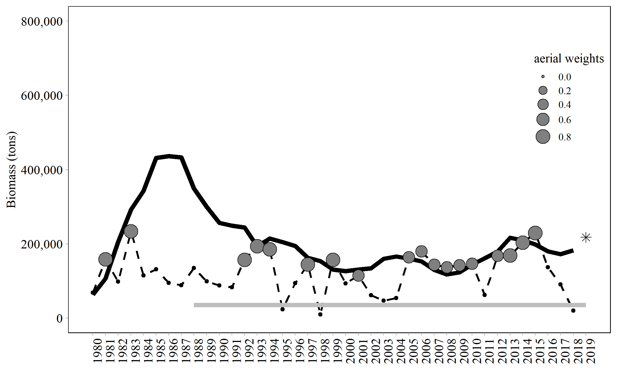

**Figure 1:** Aerial survey-estimated biomass plus pre-peak catch that were included in the model (grey points), model-estimated mature biomass (black solid line), and model-estimated mature biomass forecast (black star). The size of the grey points reflect the confidence weighting of each aerial survey estimate in the model based on weather, number of surveys, quality of surveys, and timing of surveys relative to the spawn (ranging from 0=no confidence to 1=perfect confidence). The grey line denotes the threshold.

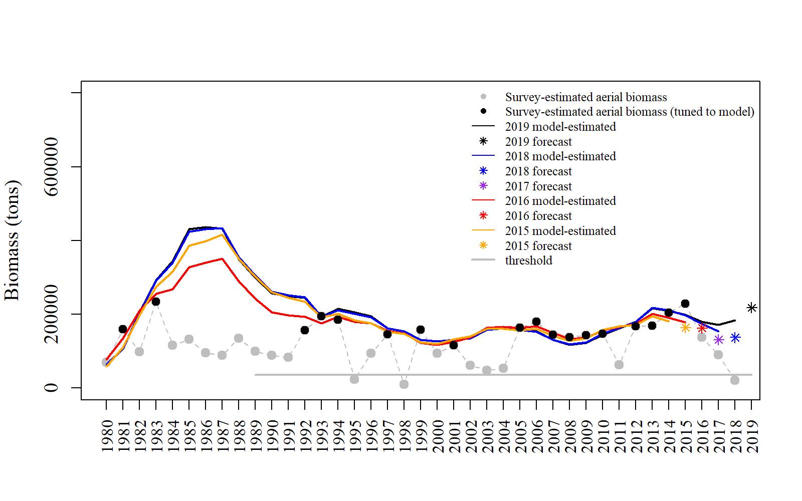

**Figure 2:** Comparison of past and current survey-estimated mature biomass (aerial survey-estimated biomass plus pre-peak catch; black and grey points with grey dashed line), model-estimated mature biomass (solid lines), and model-estimated mature biomass forecasts (stars).

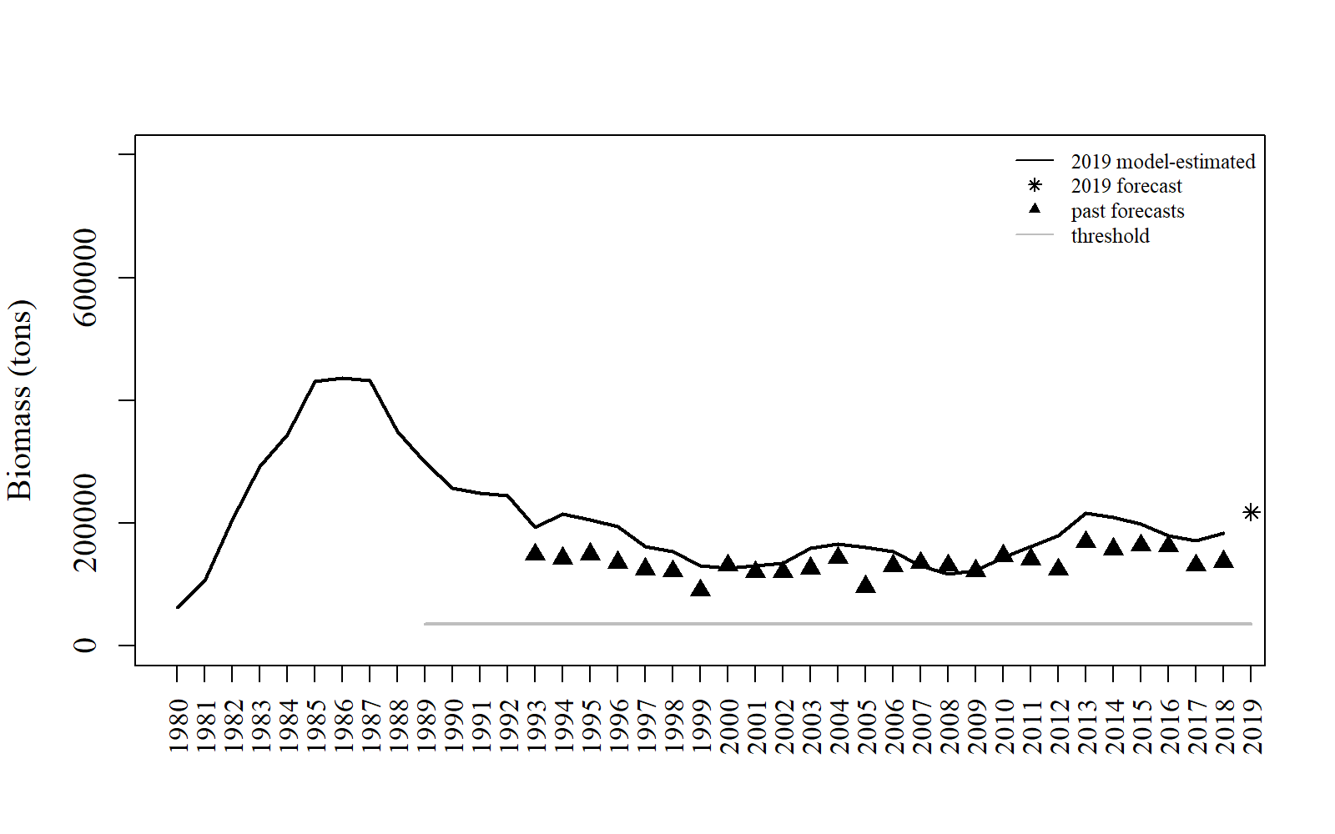**Figure 3:** Comparison of model-estimated mature biomass, 2019 forecast, and past forecasts to show past forecast performance. The 2017-forecast biomass was the average spawning biomass for all years for which there was data (1978­­–2015) less 10% in order to be conservative (a final estimate of 130,852 tons; Alaska Department of Fish and Game Commercial Fisheries news release 3 October 2016).

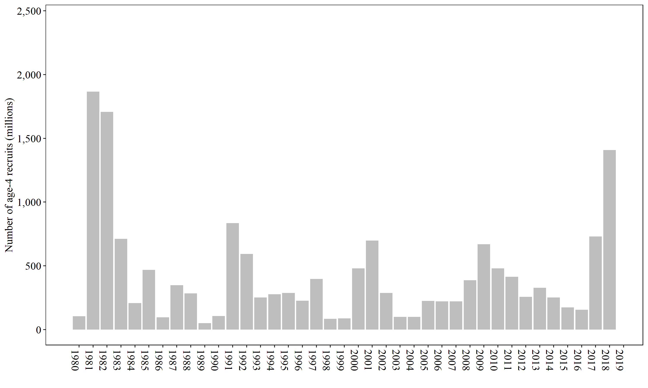

**Figure 4:** Model estimates of age-4 recruit strength (numbers of age-4 mature and immature fish).

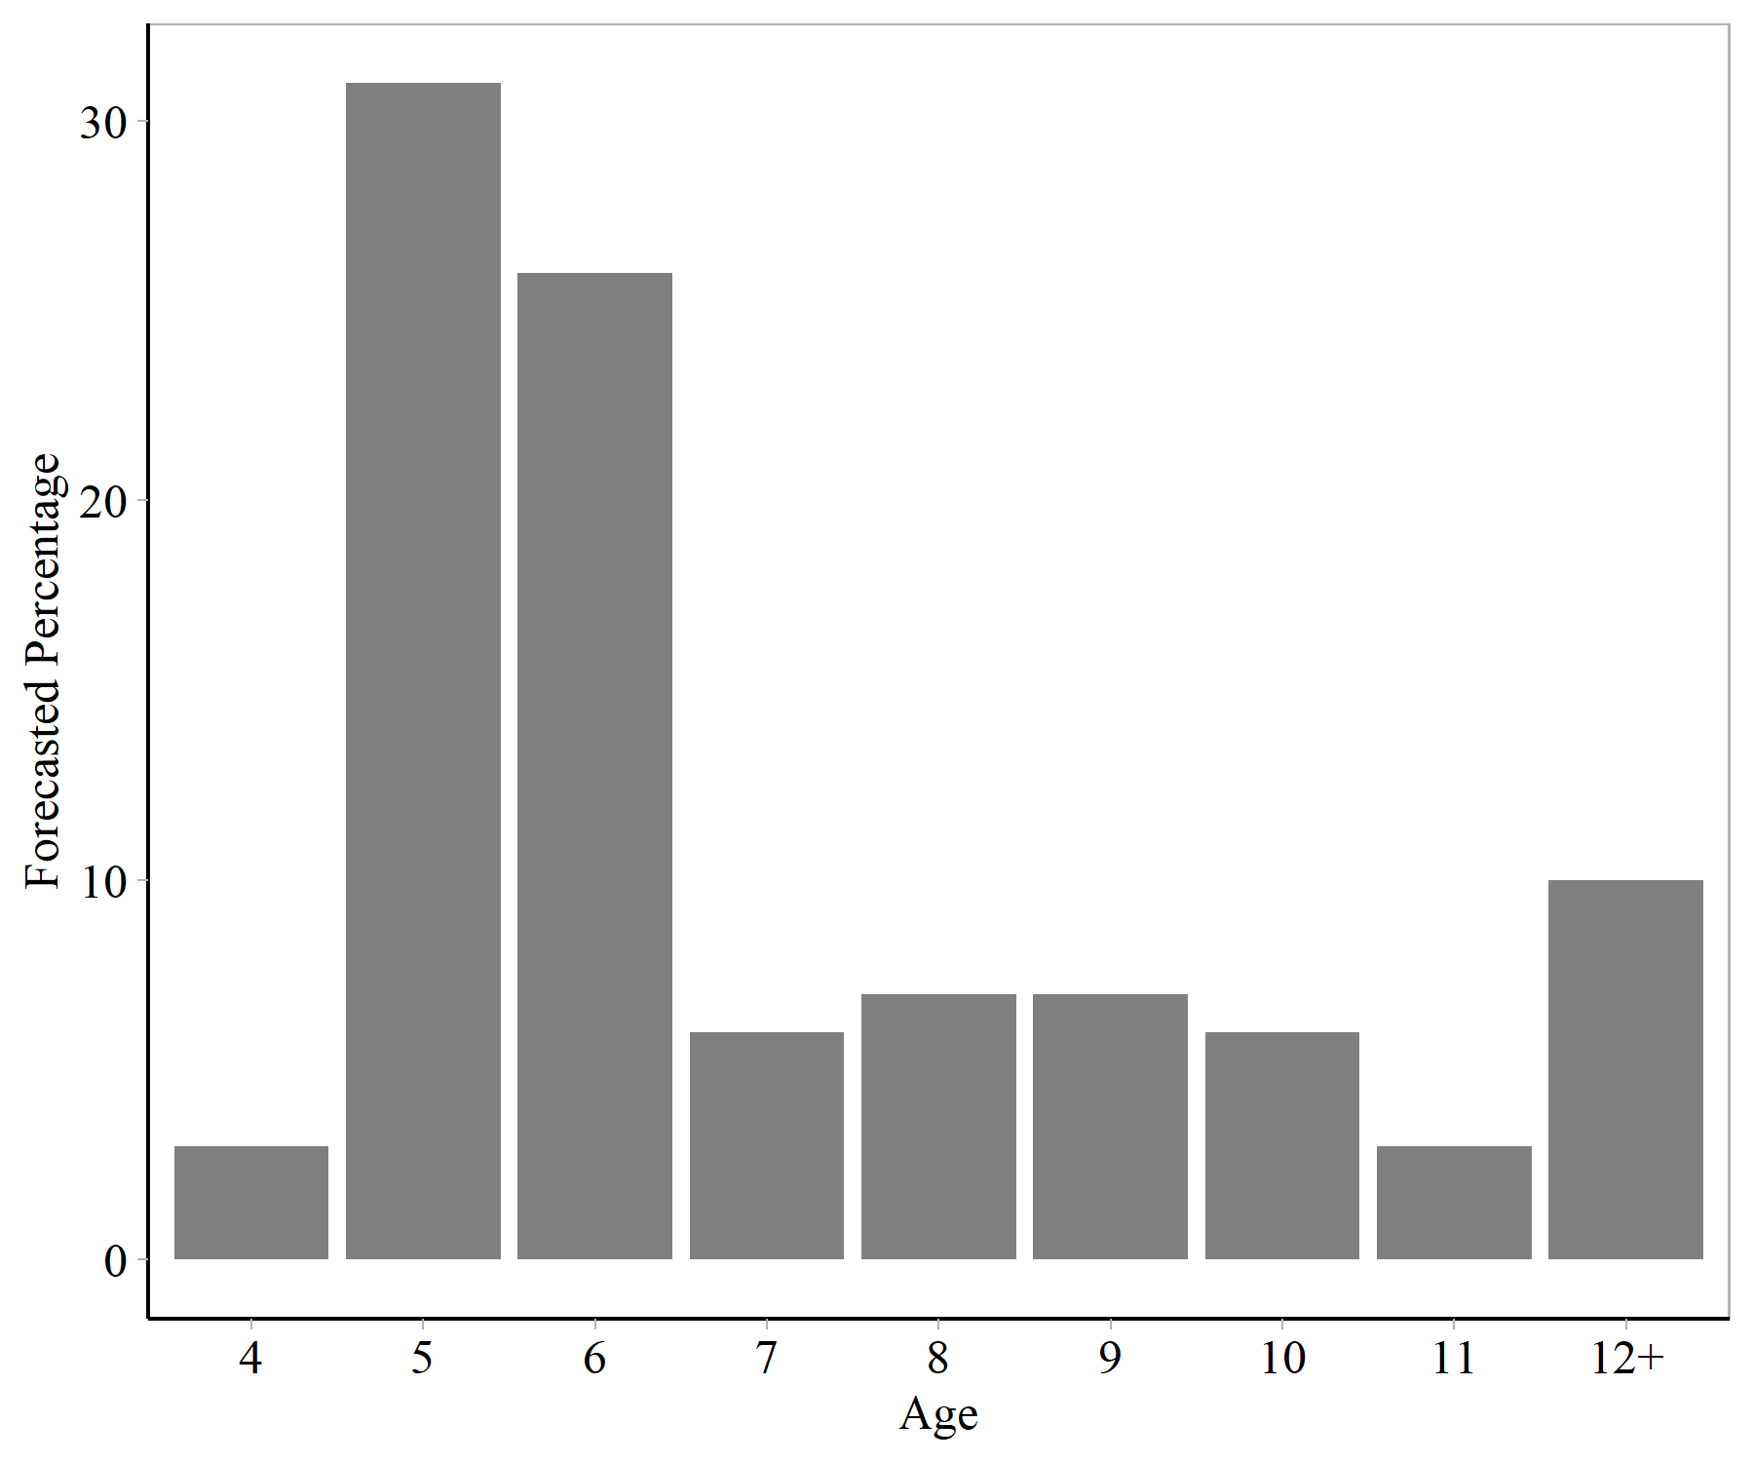

**Figure 5:** Forecasted percentage of mature numbers at age for forecast year. The percent of age-4 fish was estimated with a 10-yr (2007–2016) median of past recruitments.

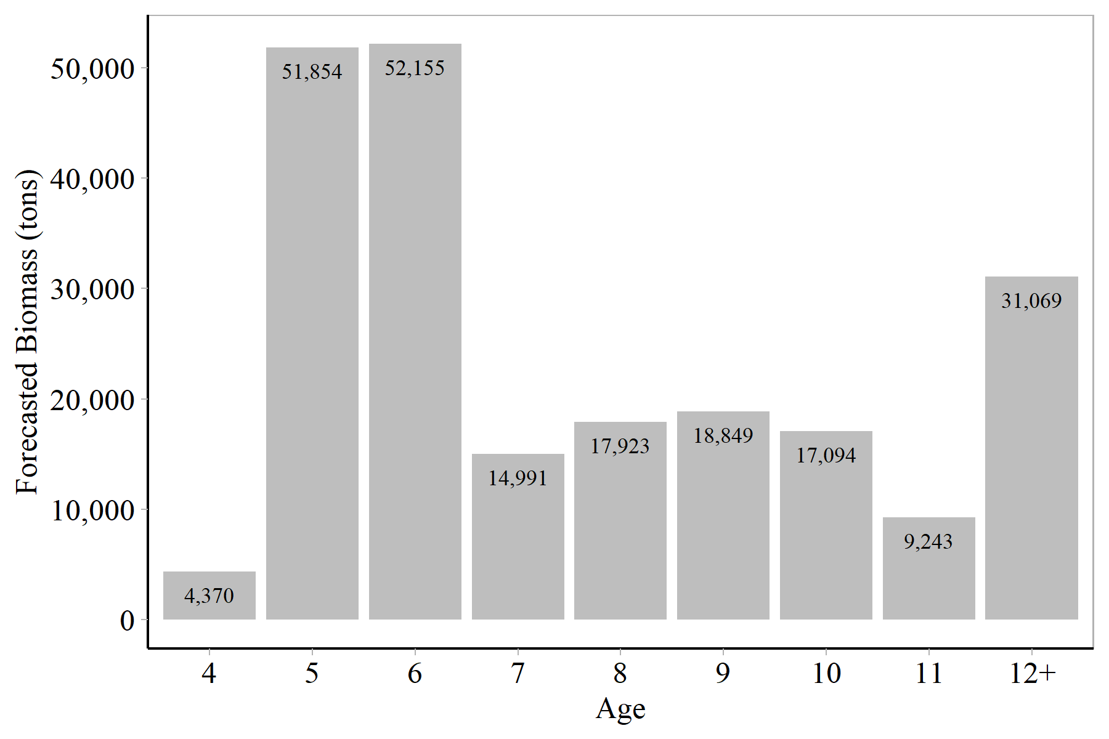

**Figure 6:** Forecasted mature biomass at age (tons) for forecast year.

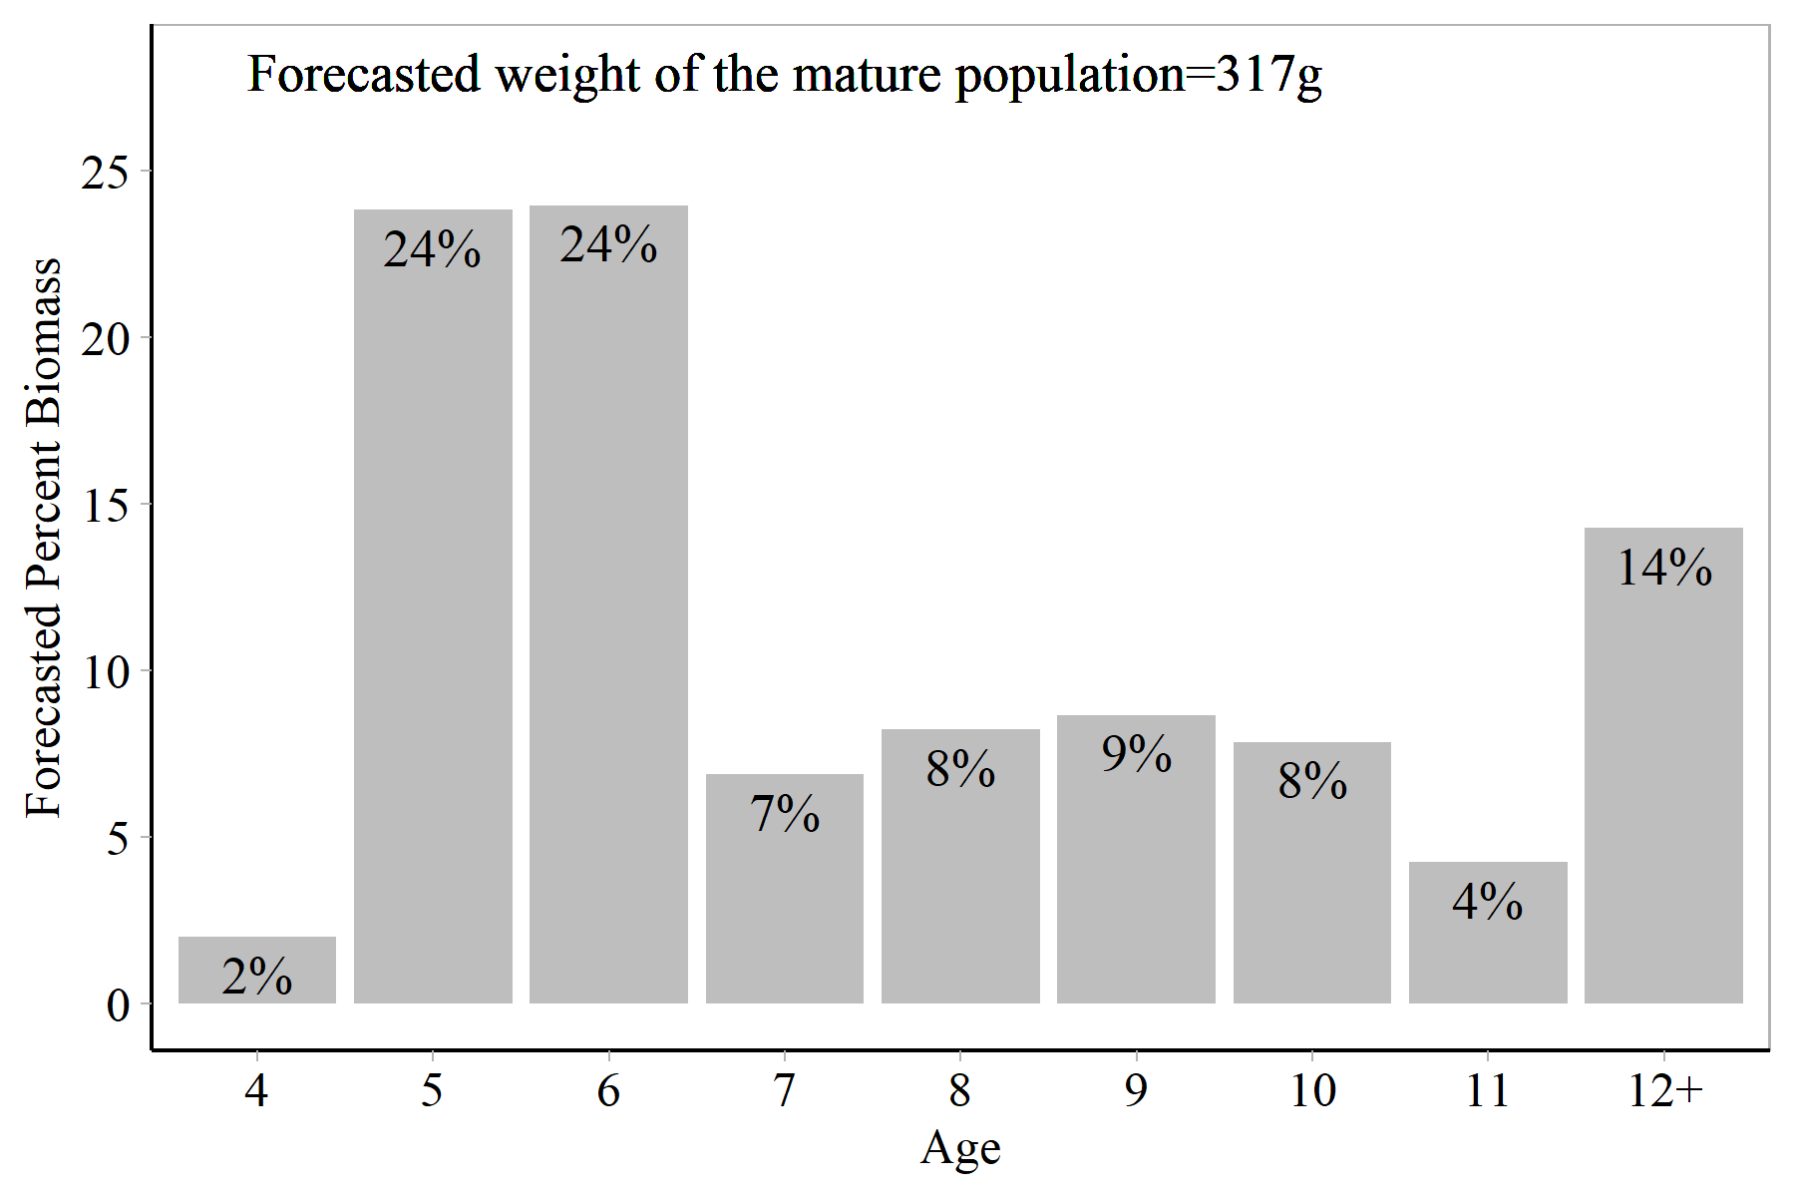

**Figure 7:** Forecasted percent mature biomass at age (tons) for forecast year with the forecasted weight of the mature population.

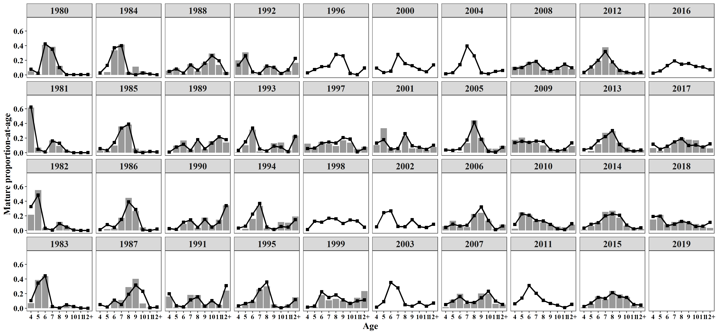

**Figure 8:** Comparison of observed (bars) and model-estimated (line with points) mature age compositions. Observed samples used to estimate age composition of the mature population biomass in 2018 were weighted based on the commercial purse seine harvests on days of the pre-peak harvest (purse seine harvest and age composition data through 1 May), peak survey biomass on 2 May (purse seine age composition data through 1 May), post season survey biomass on 16 May (age composition data from the purse seine harvests on 2 May), and gillnet commercial harvest on days of the pre-peak harvest (harvest and age composition data through 1 May).

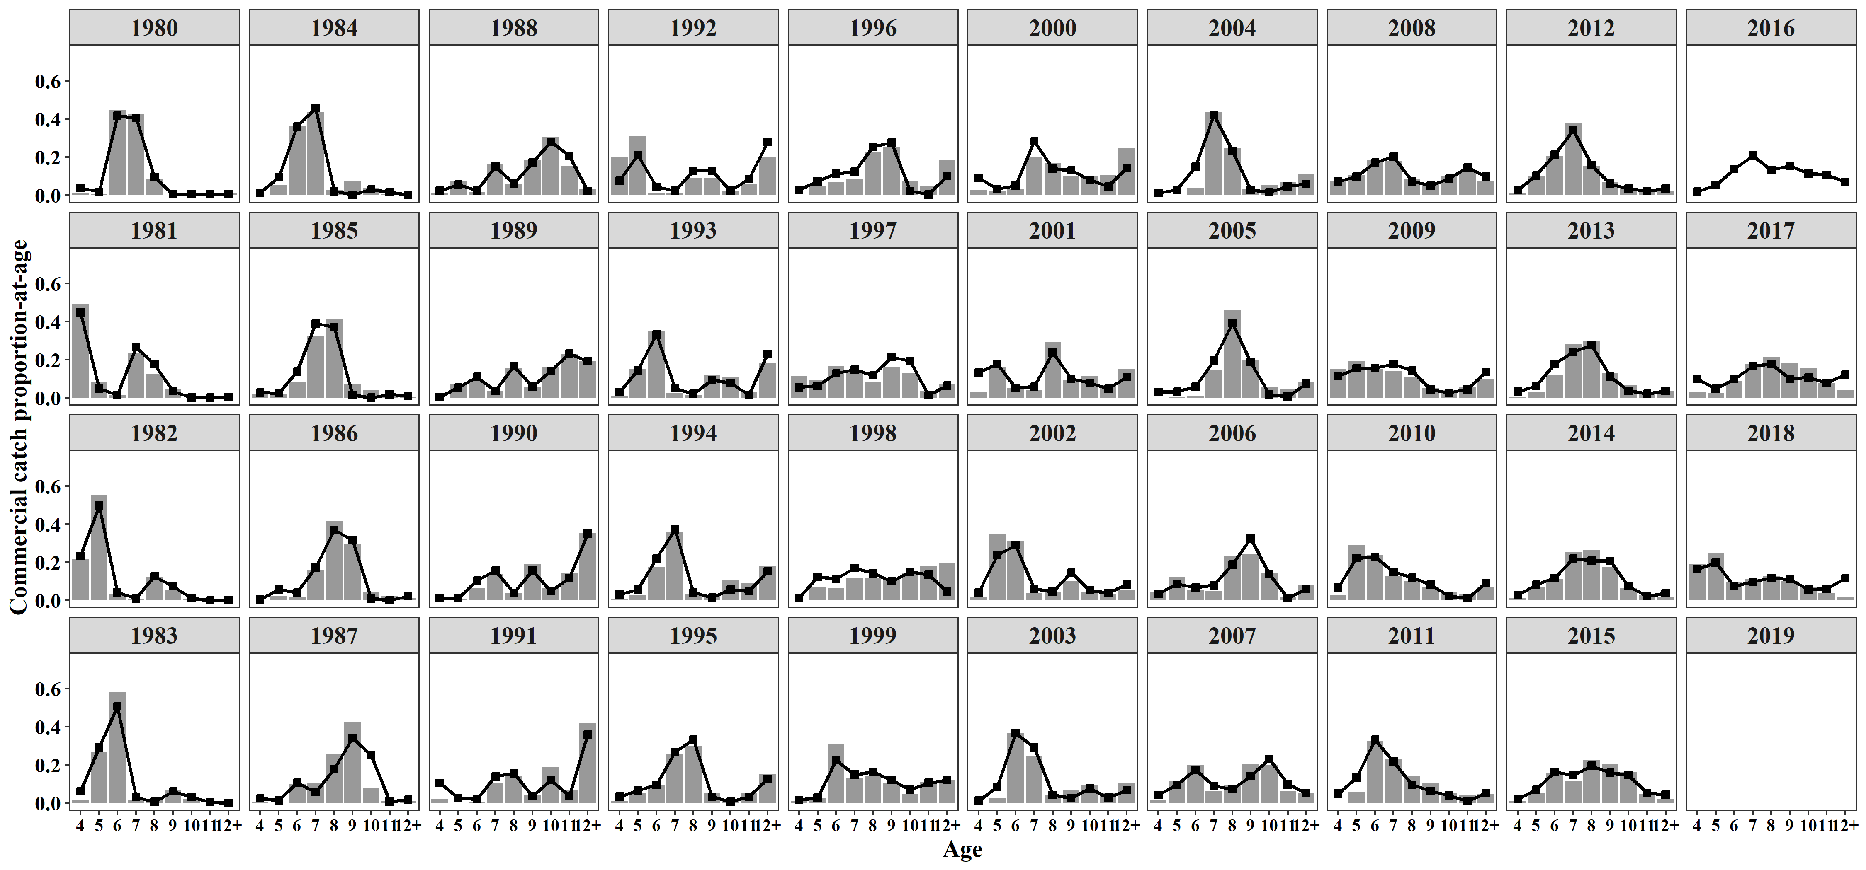

**Figure 9:** Observed (bars) and model-estimated (black line with points) purse seine catch-age composition. Observed samples used to estimate age composition of the seine population biomass in 2018 were weighted based on five groups (age composition data through 25 April, age composition data on 26 April, age composition data on 27–28 April, age composition on 29–30 April, age composition data on 1 May, and age composition data on 2 May).

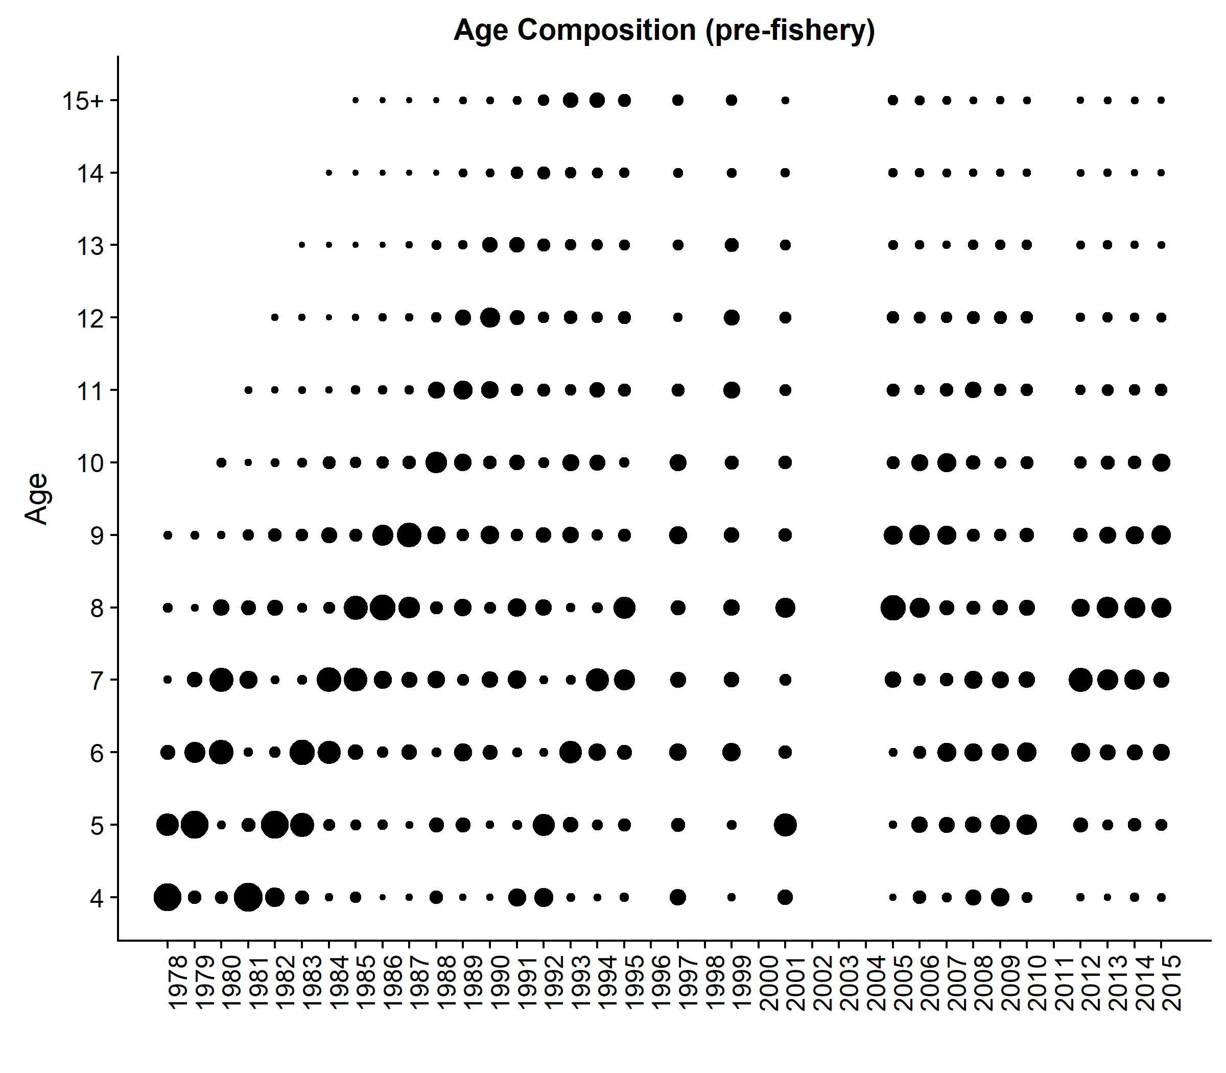

**Figure 10:** Togiak herring mature population age composition by year from commercial purse seine samples. Size of the dots are proportional to percent age composition within a year.

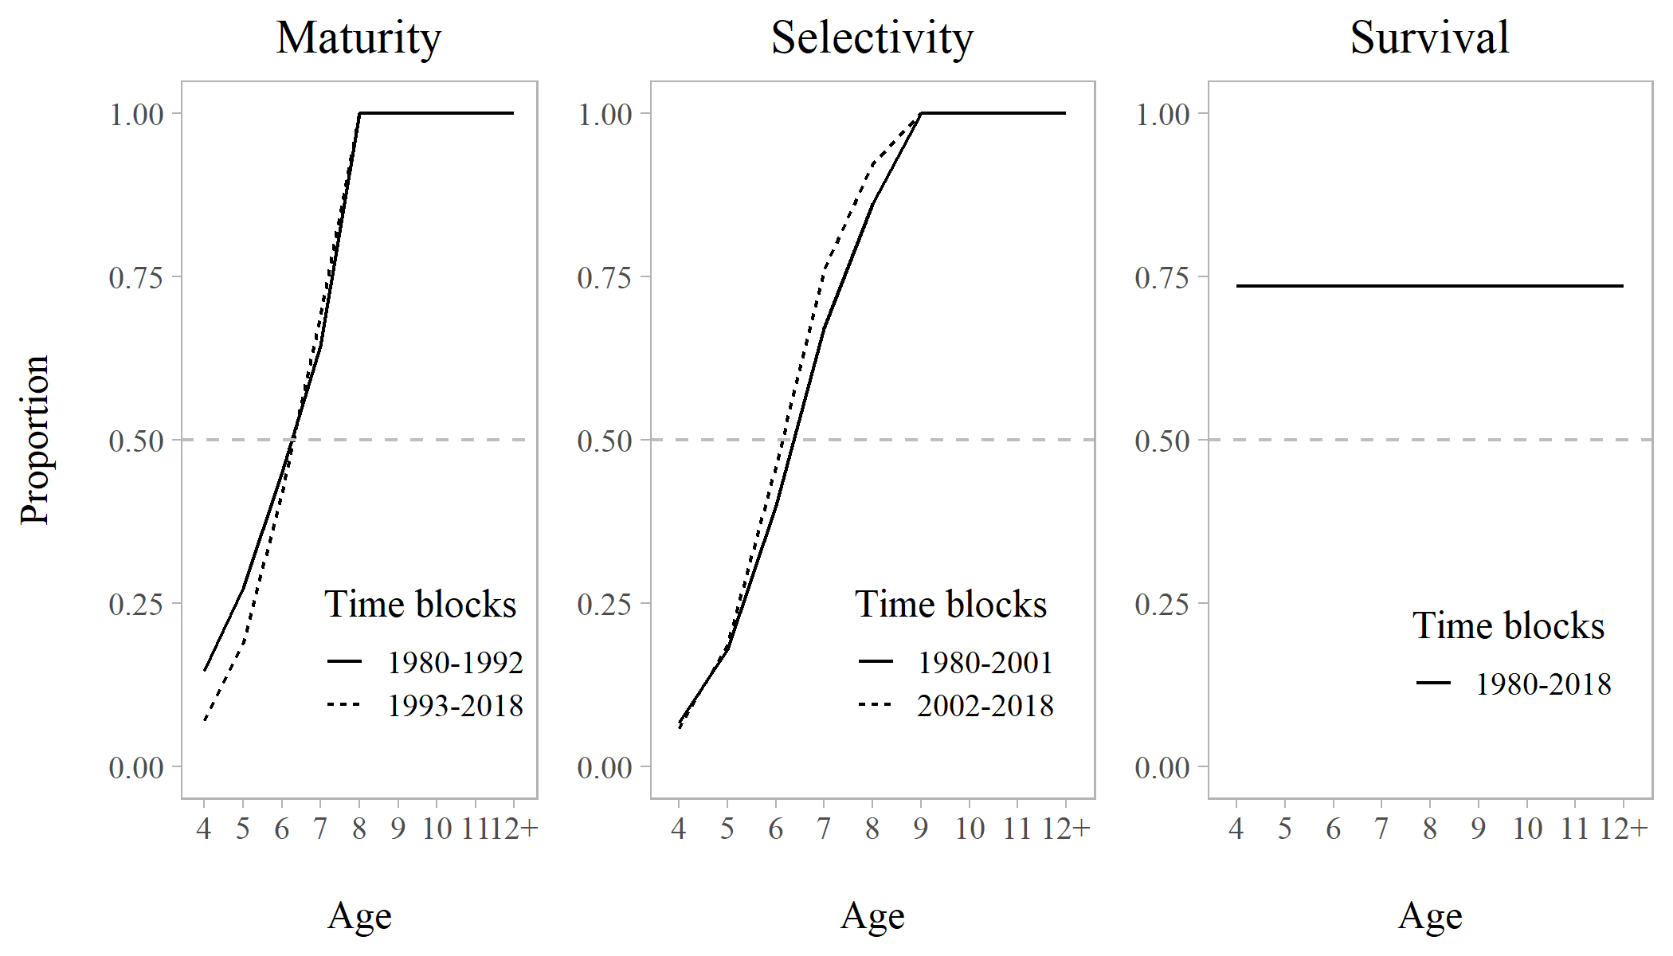

**Figure 11:** Model estimates of maturity, purse seine selectivity, and survival by time blocks. Model estimates of maturity for ages 4–7 are estimated with a logistic function; estimates for 8–12+ are fixed at 1. Model estimates of purse seine selectivity for ages 4–8 are estimated with a logistic function; estimates for 9–12+ are fixed at 1. Survival is constant across age and years.

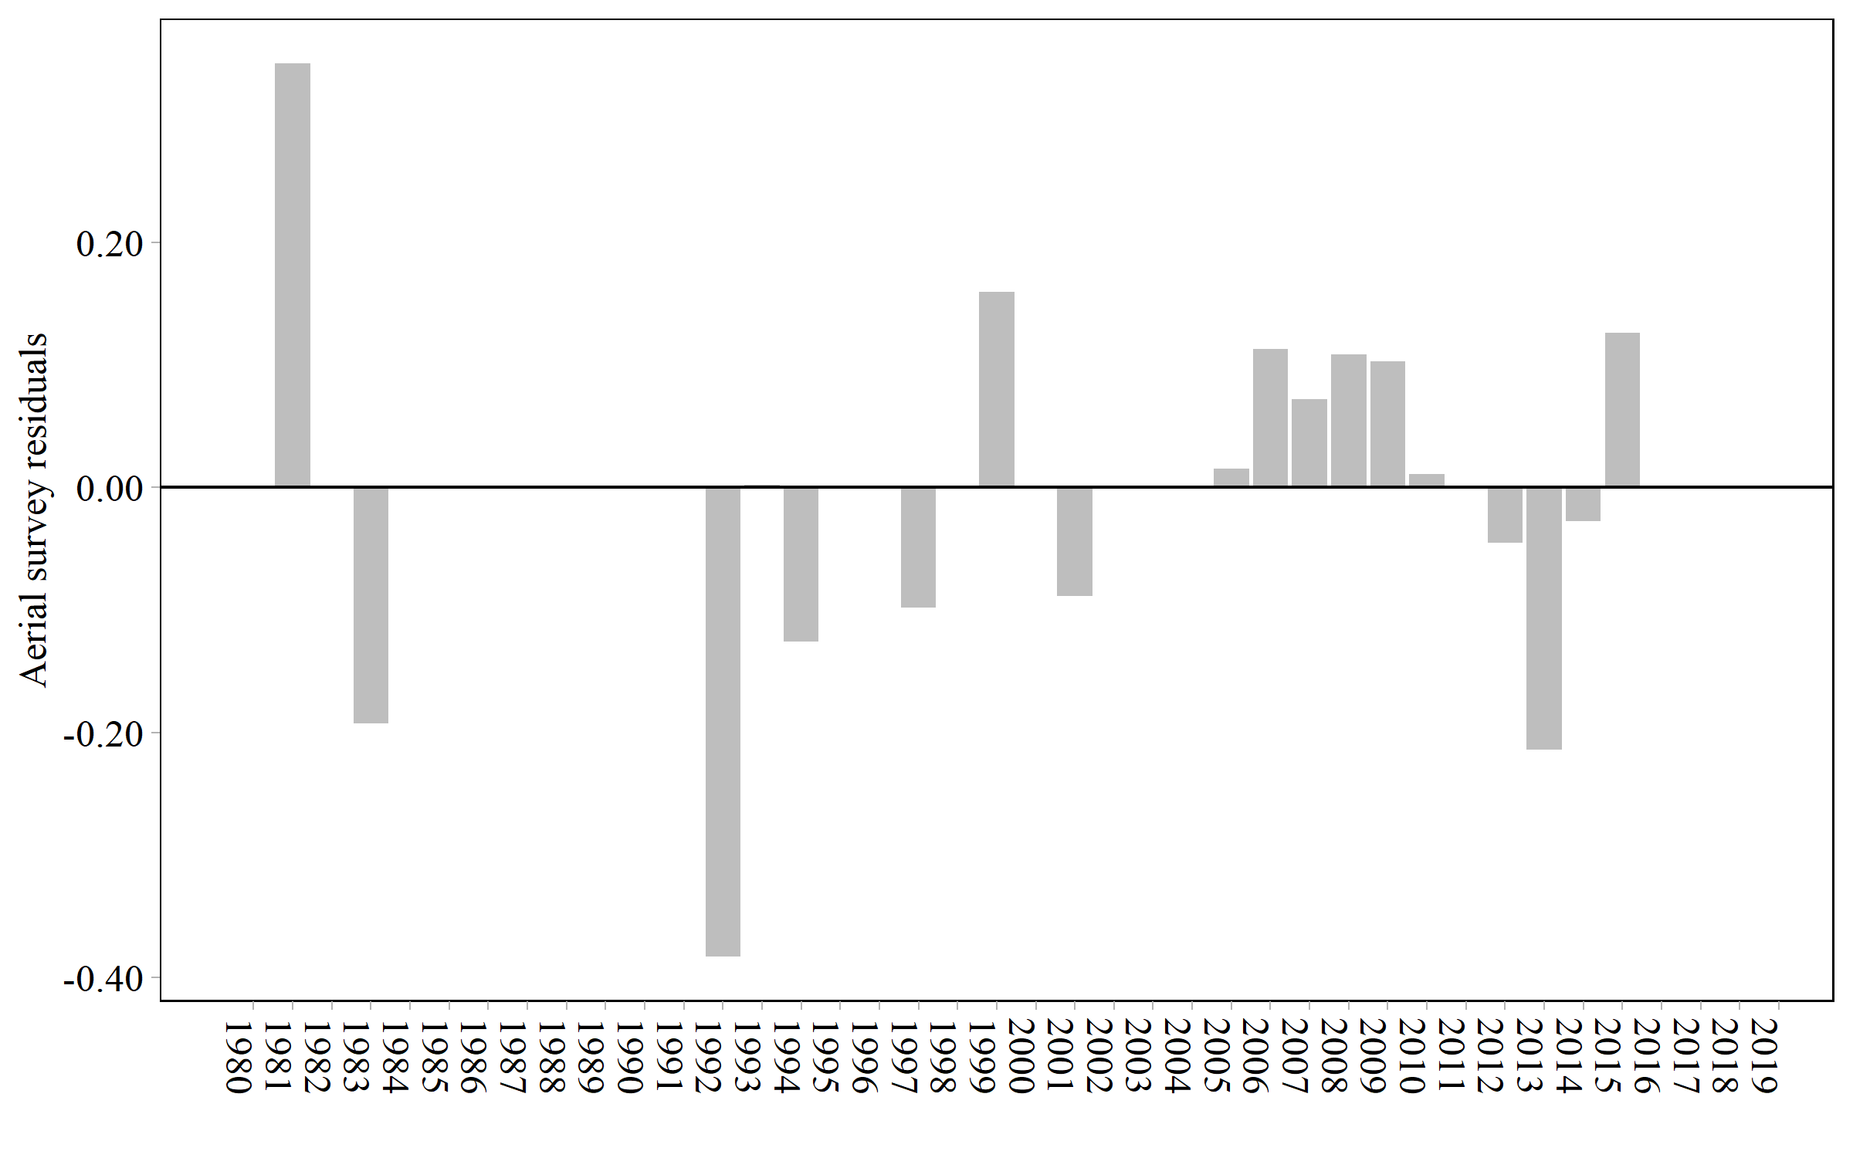**Figure 12:** Residuals from model fits to aerial survey biomass plus pre-peak harvest.

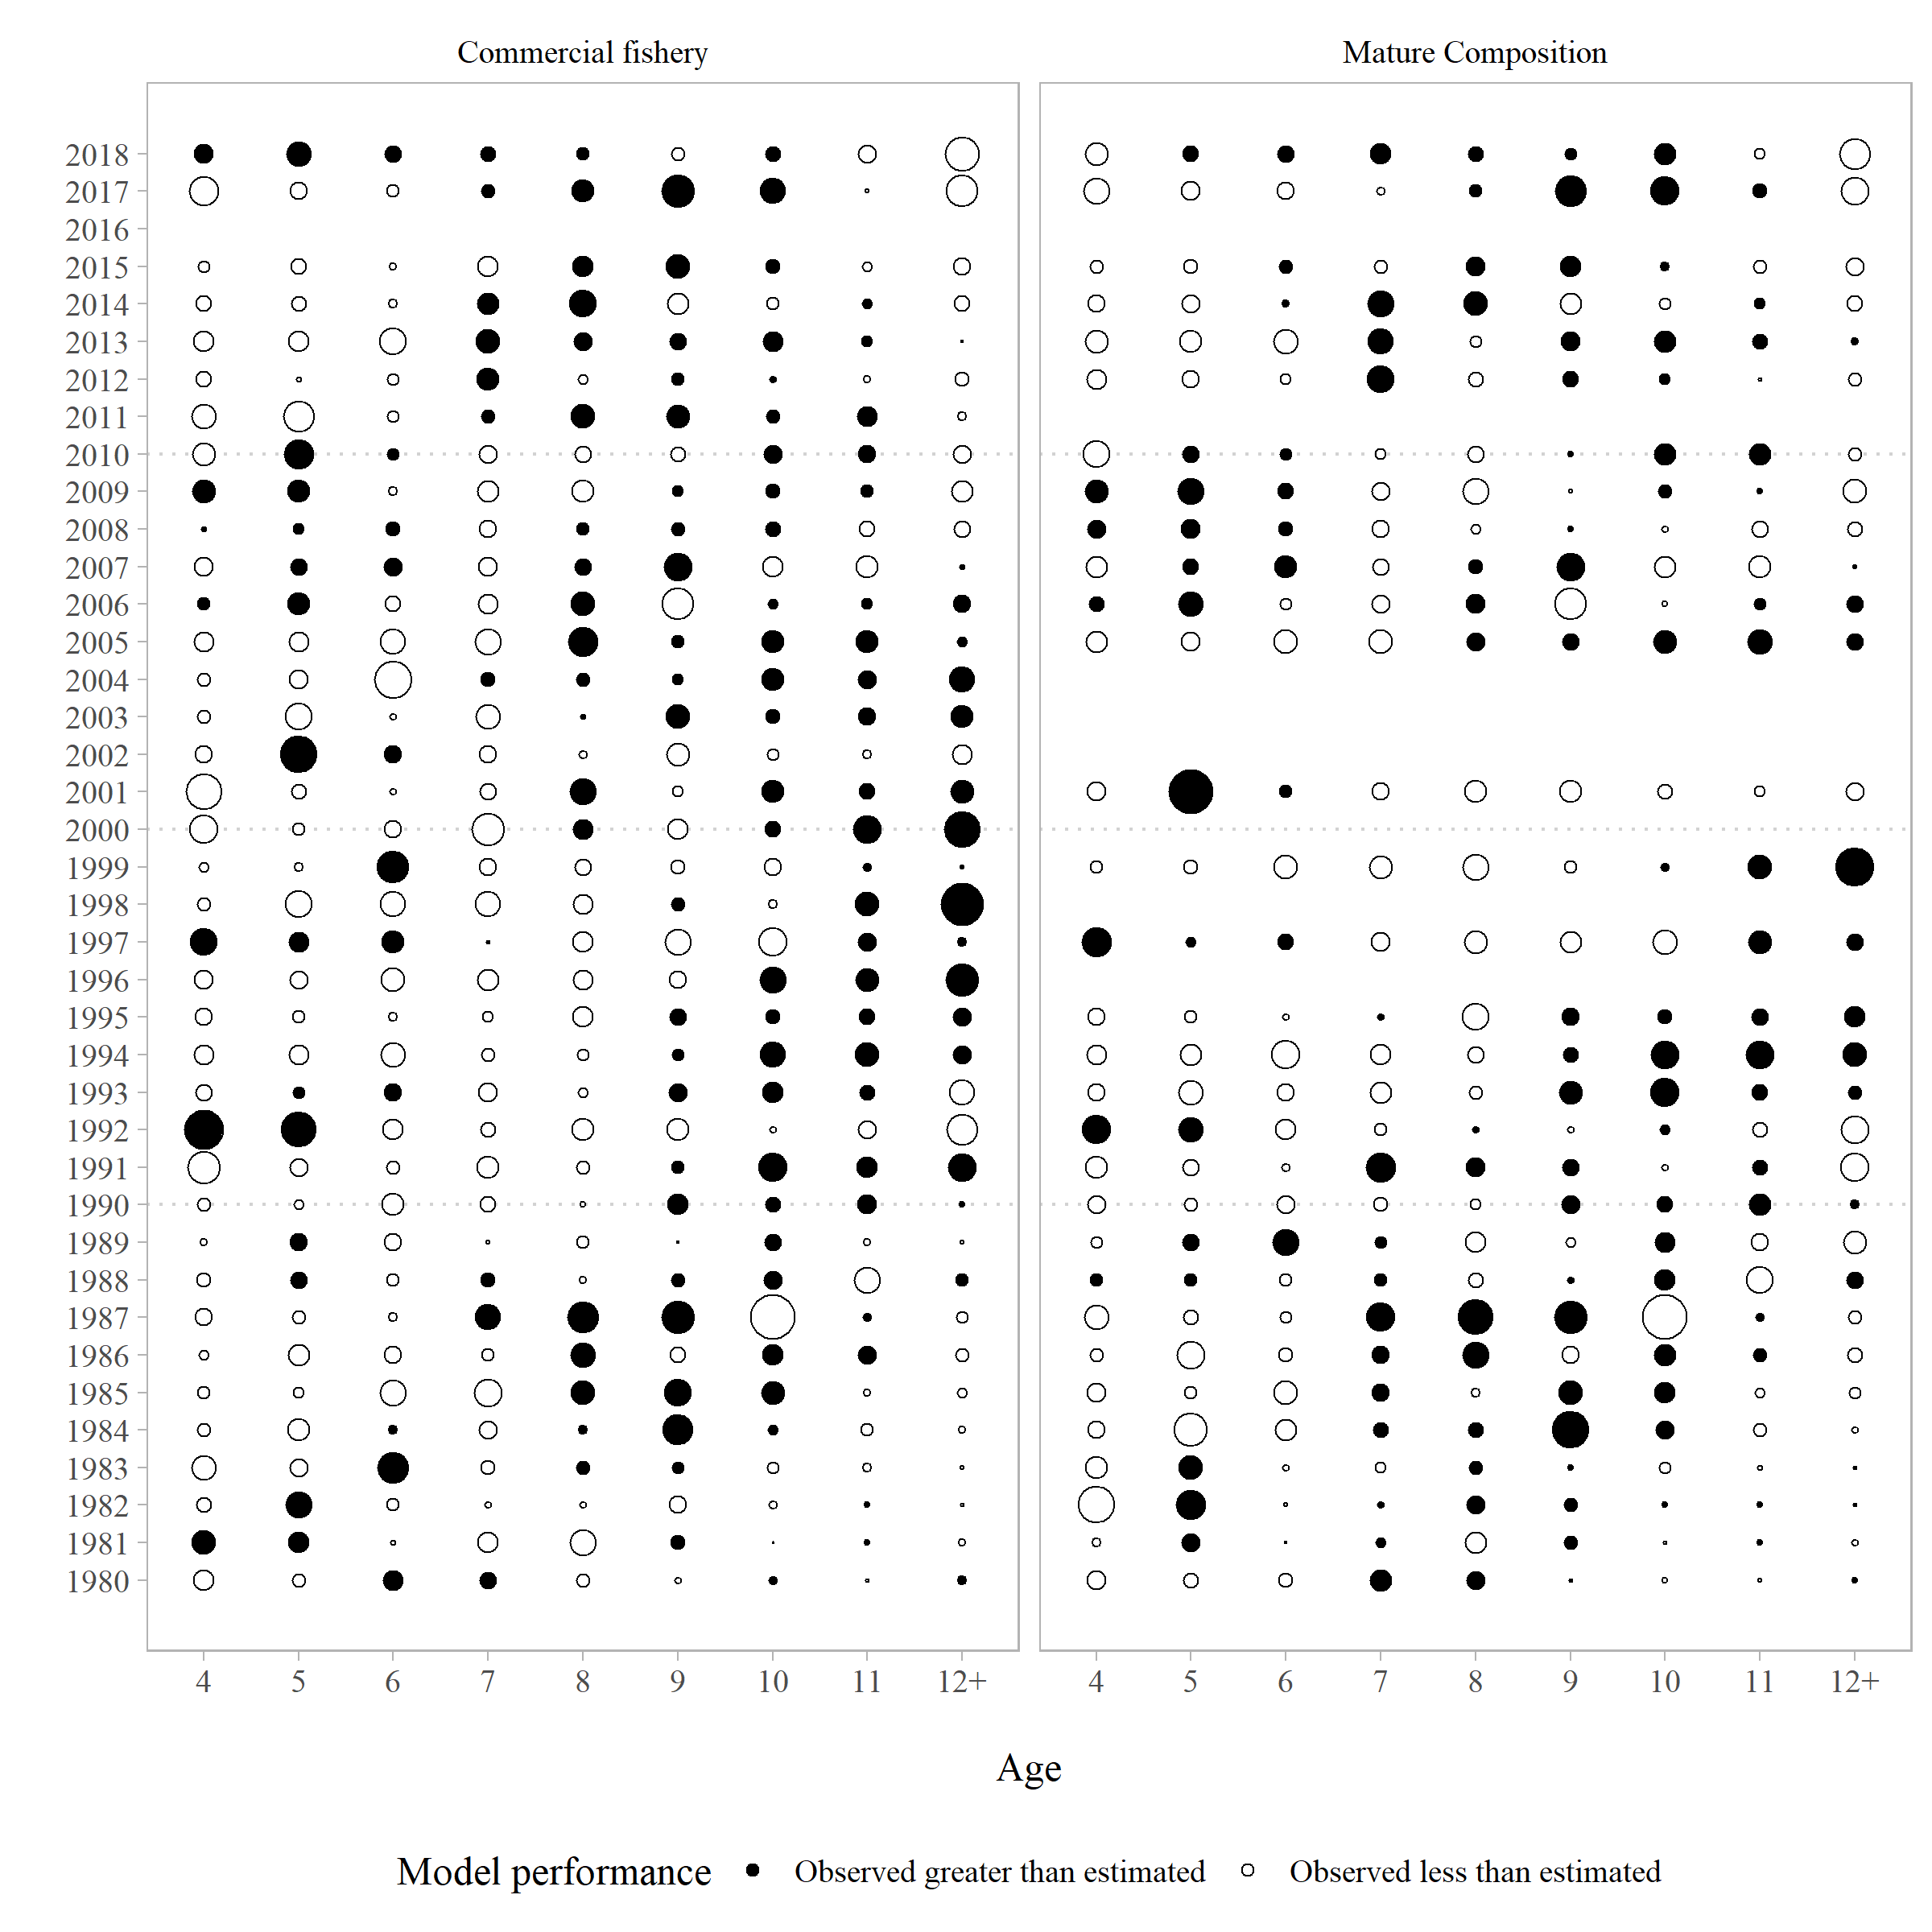

**Figure 13:** Commercial catch and mature age composition residuals.

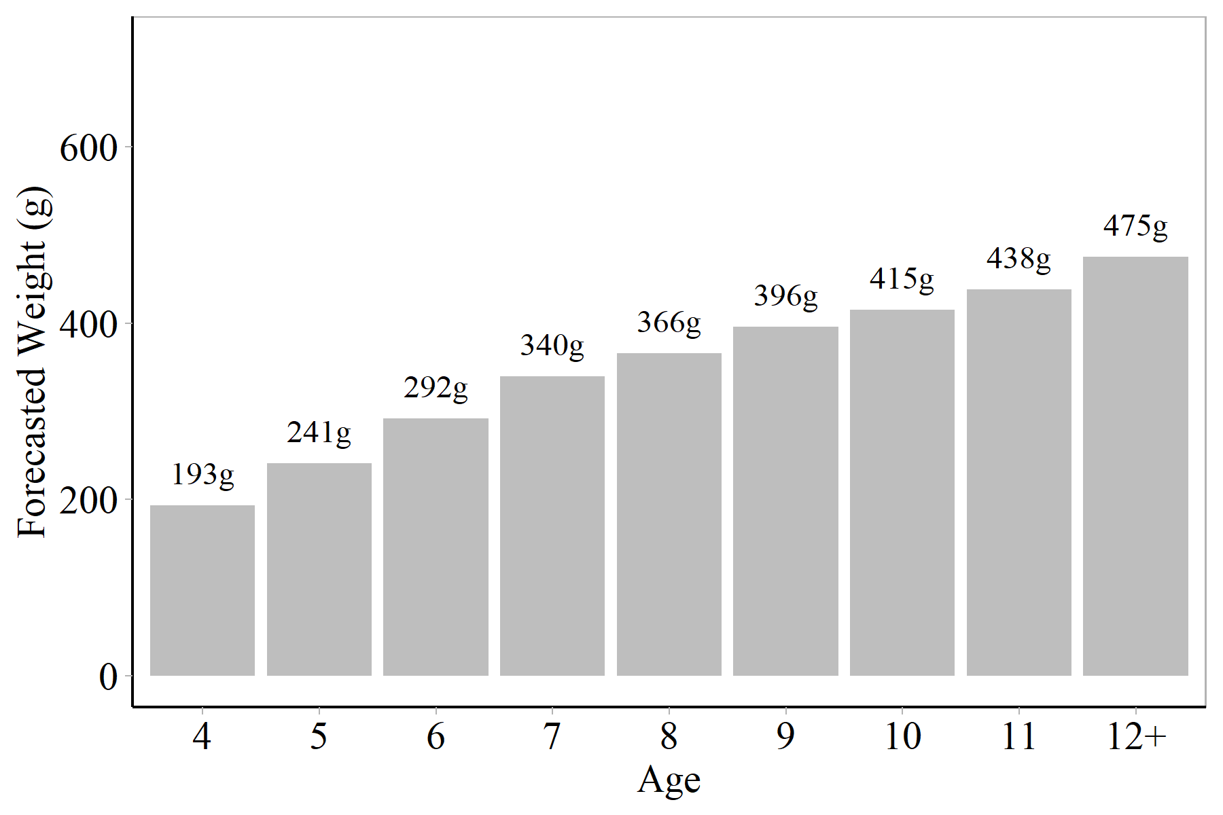

**Figure 14:** Forecasted weight at age (average weight at age from the 2017 and 2018 commercial purse seine fishery).

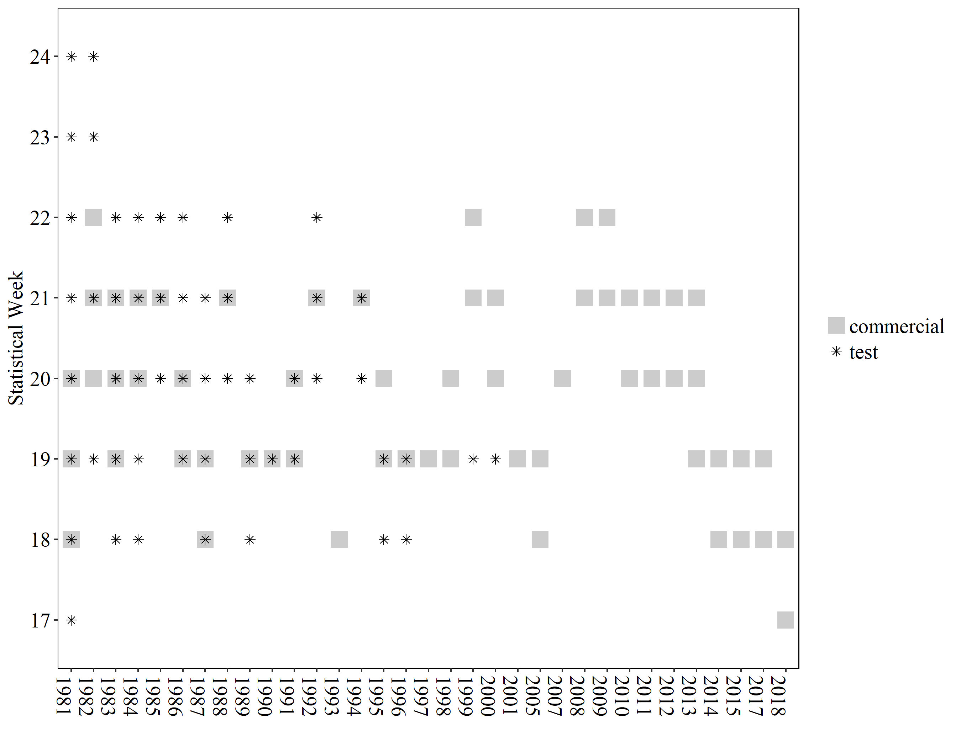

**Figure 15:** Commercial and test fishery sampling for age, sex, and length data by year and statistical week.

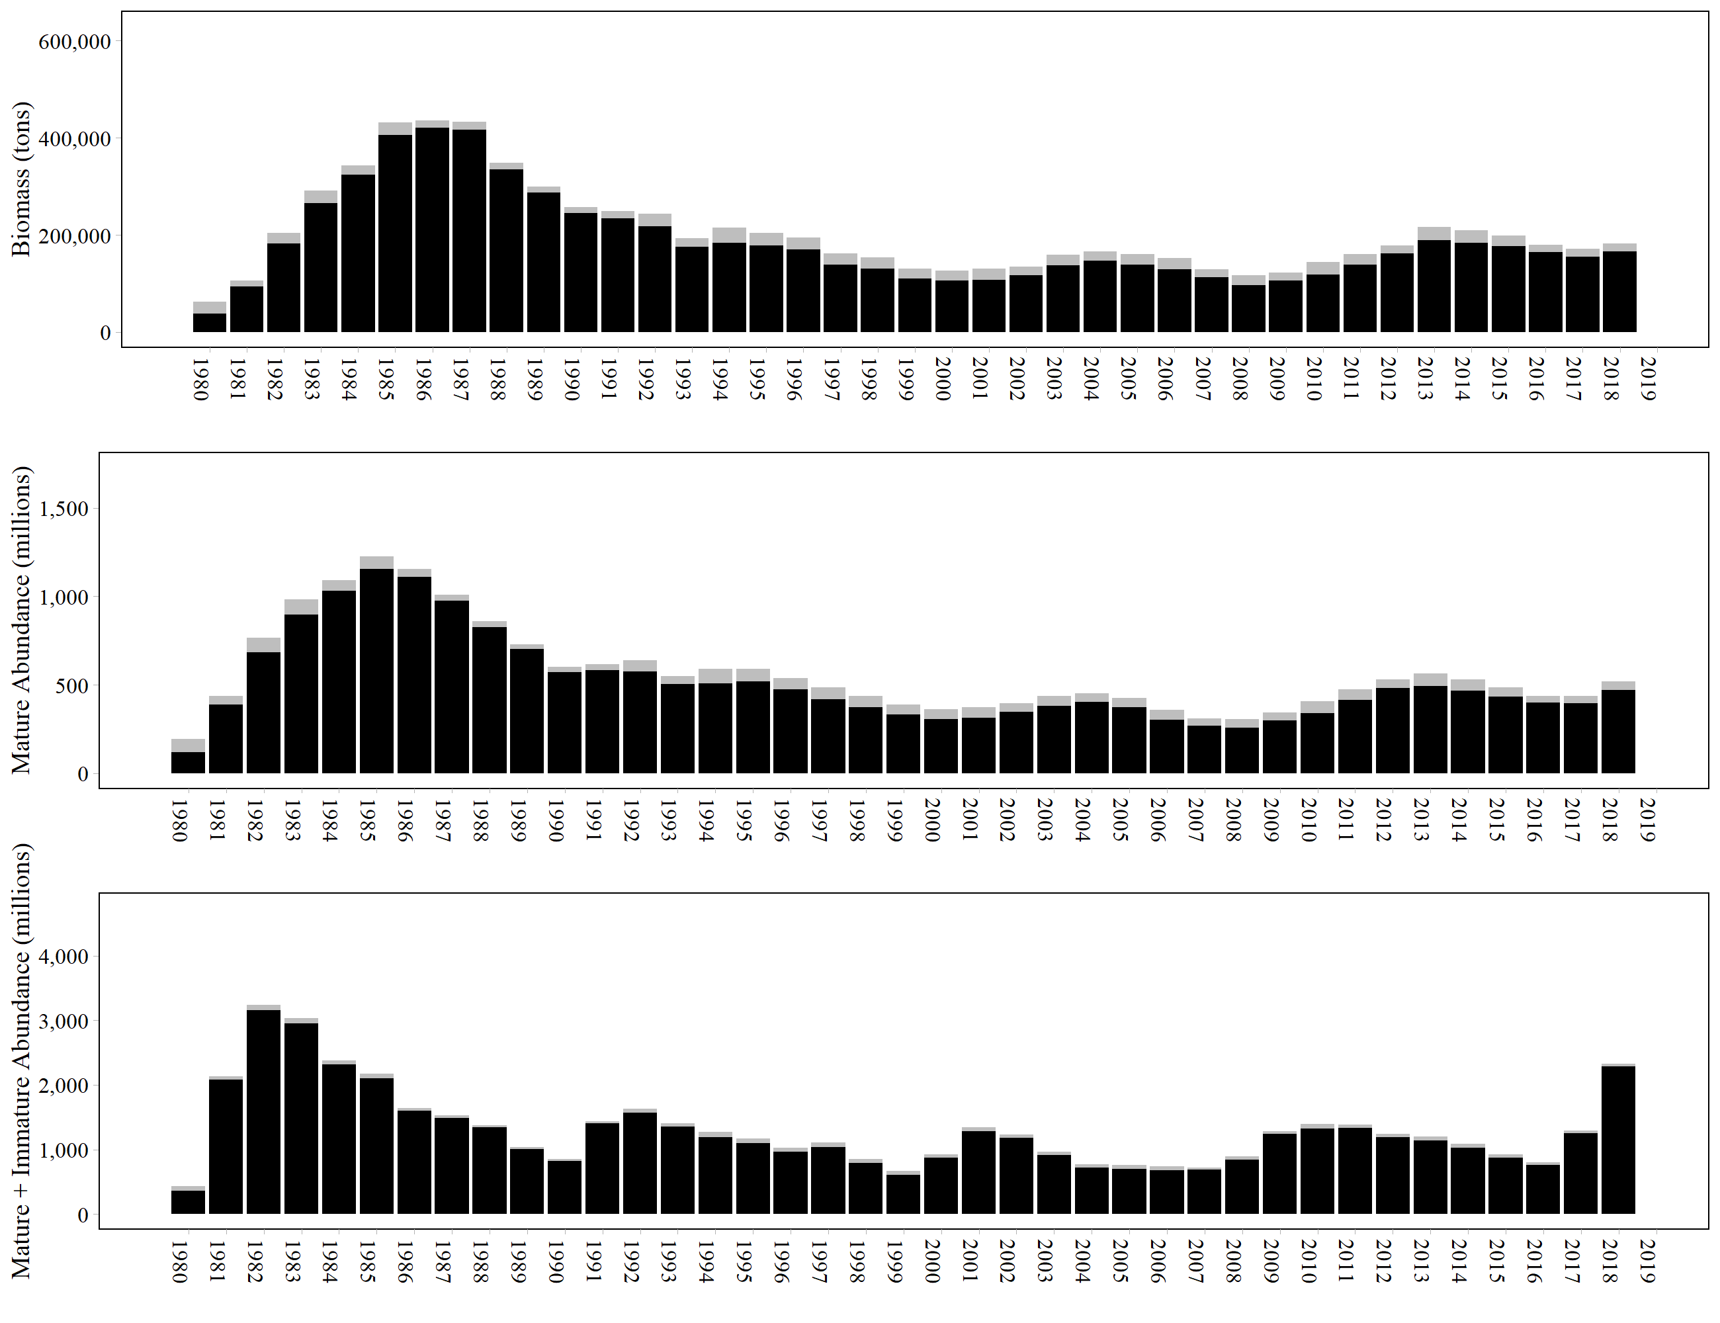

**Figure 16:** Spawning population biomass (black bars; top figure), spawning population abundance (black bars; middle figure), immature and spawning abundance (black bars; bottom figure), and commercial fishery harvest (grey bars, combined purse seine and gillnet sac roe harvest) over time. The combination of the black and grey bars (total height of each bar) is the mature biomass, mature population abundance, or total population abundance.

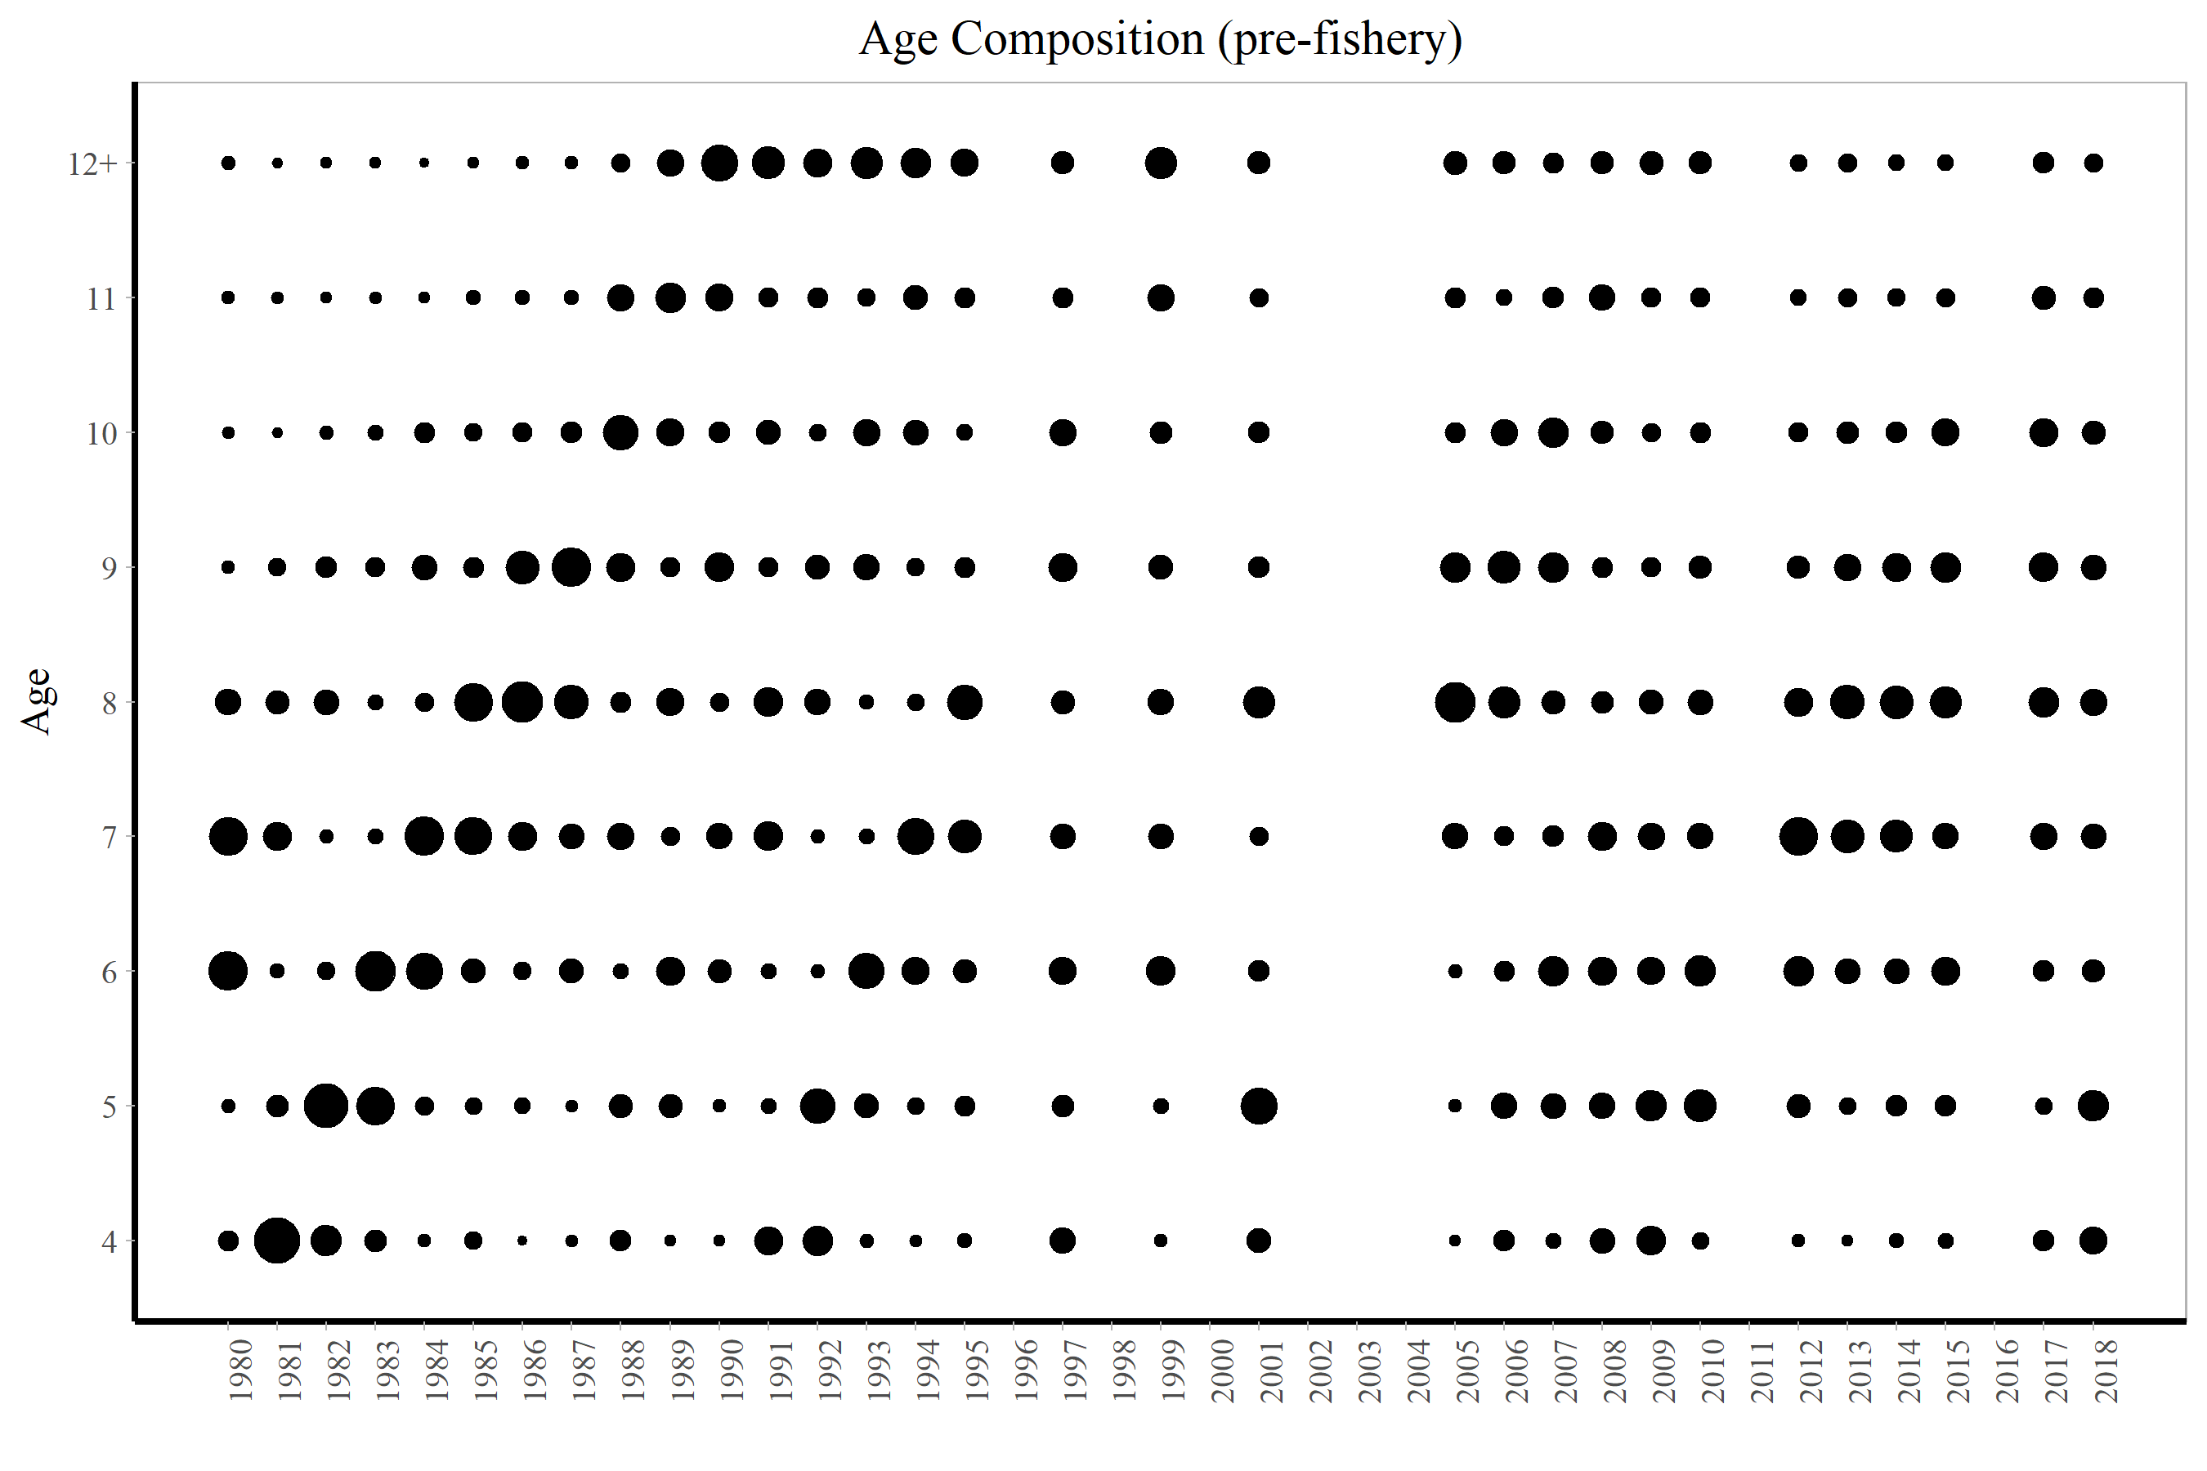

**Figure 17:** Togiak herring mature population age composition by year based on selected commercial purse seine samples. The mature population in 2018 was represented by commercial seine samples taken on the days of pre-peak (through 5/1/2018) and peak (5/2/2018) aerial surveys. Size of the dots is proportional to percent age composition within a year.

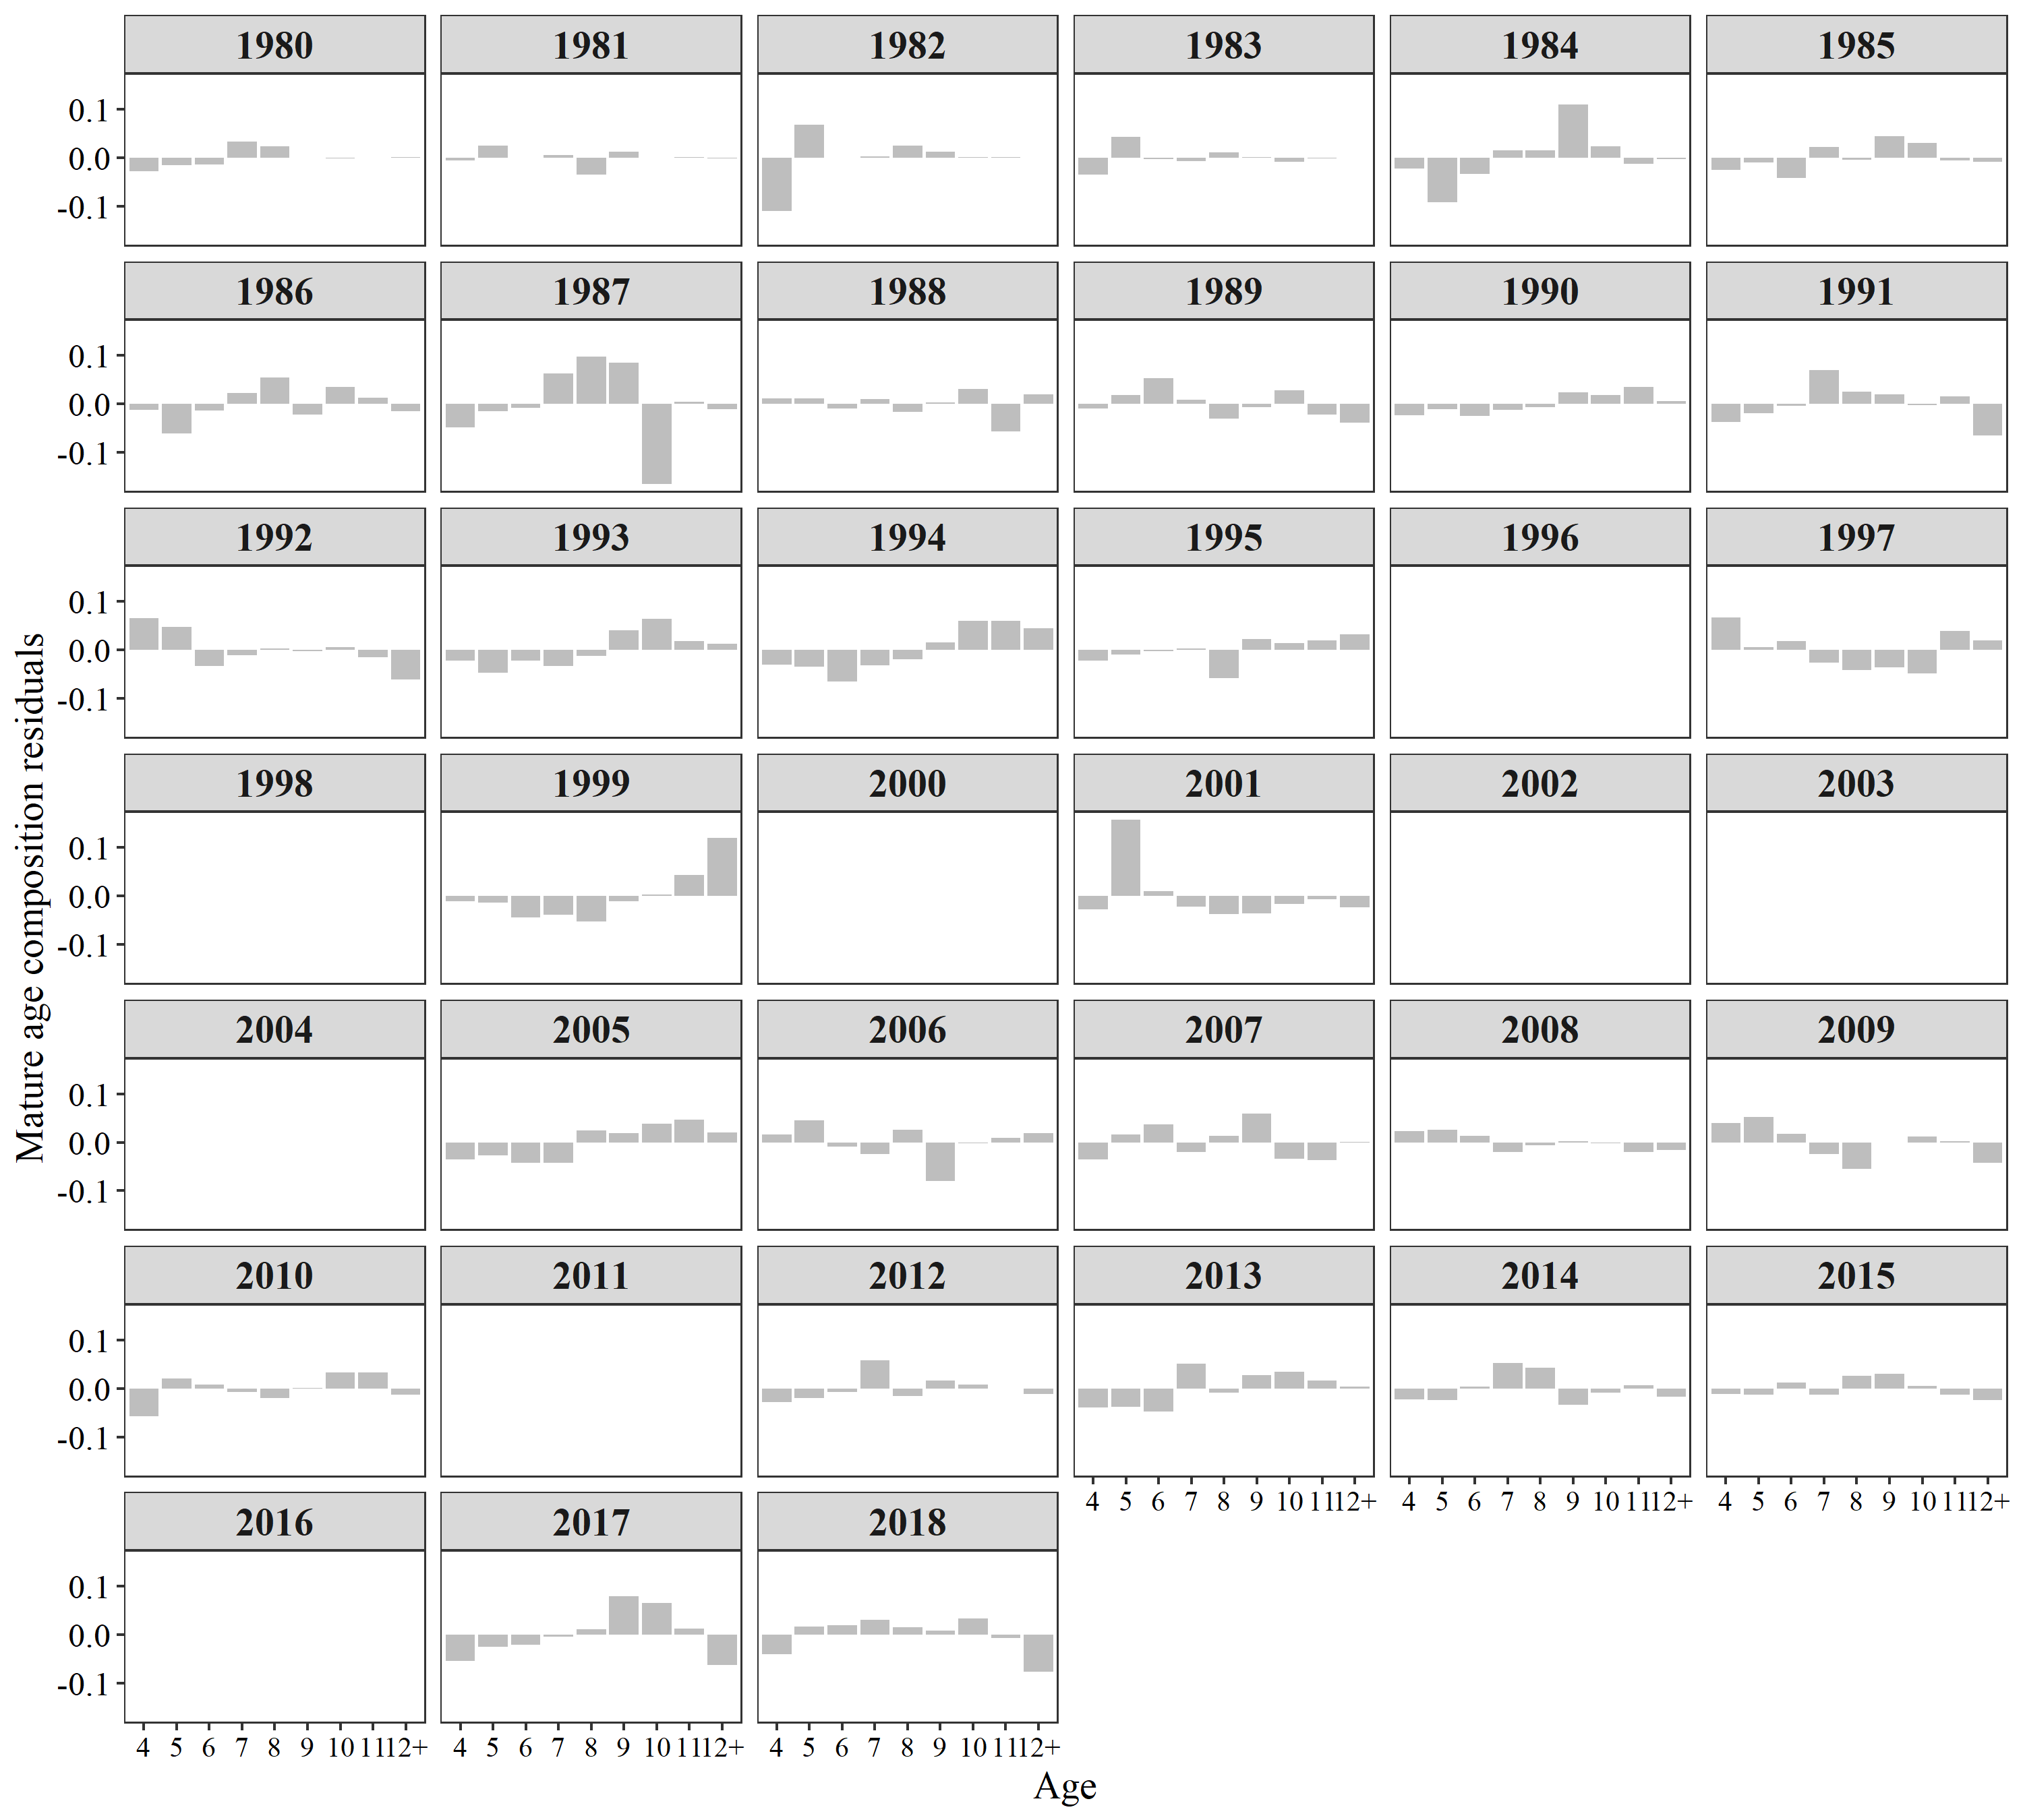

**Figure 18:** Residuals from model fits to age compositions of the mature population.

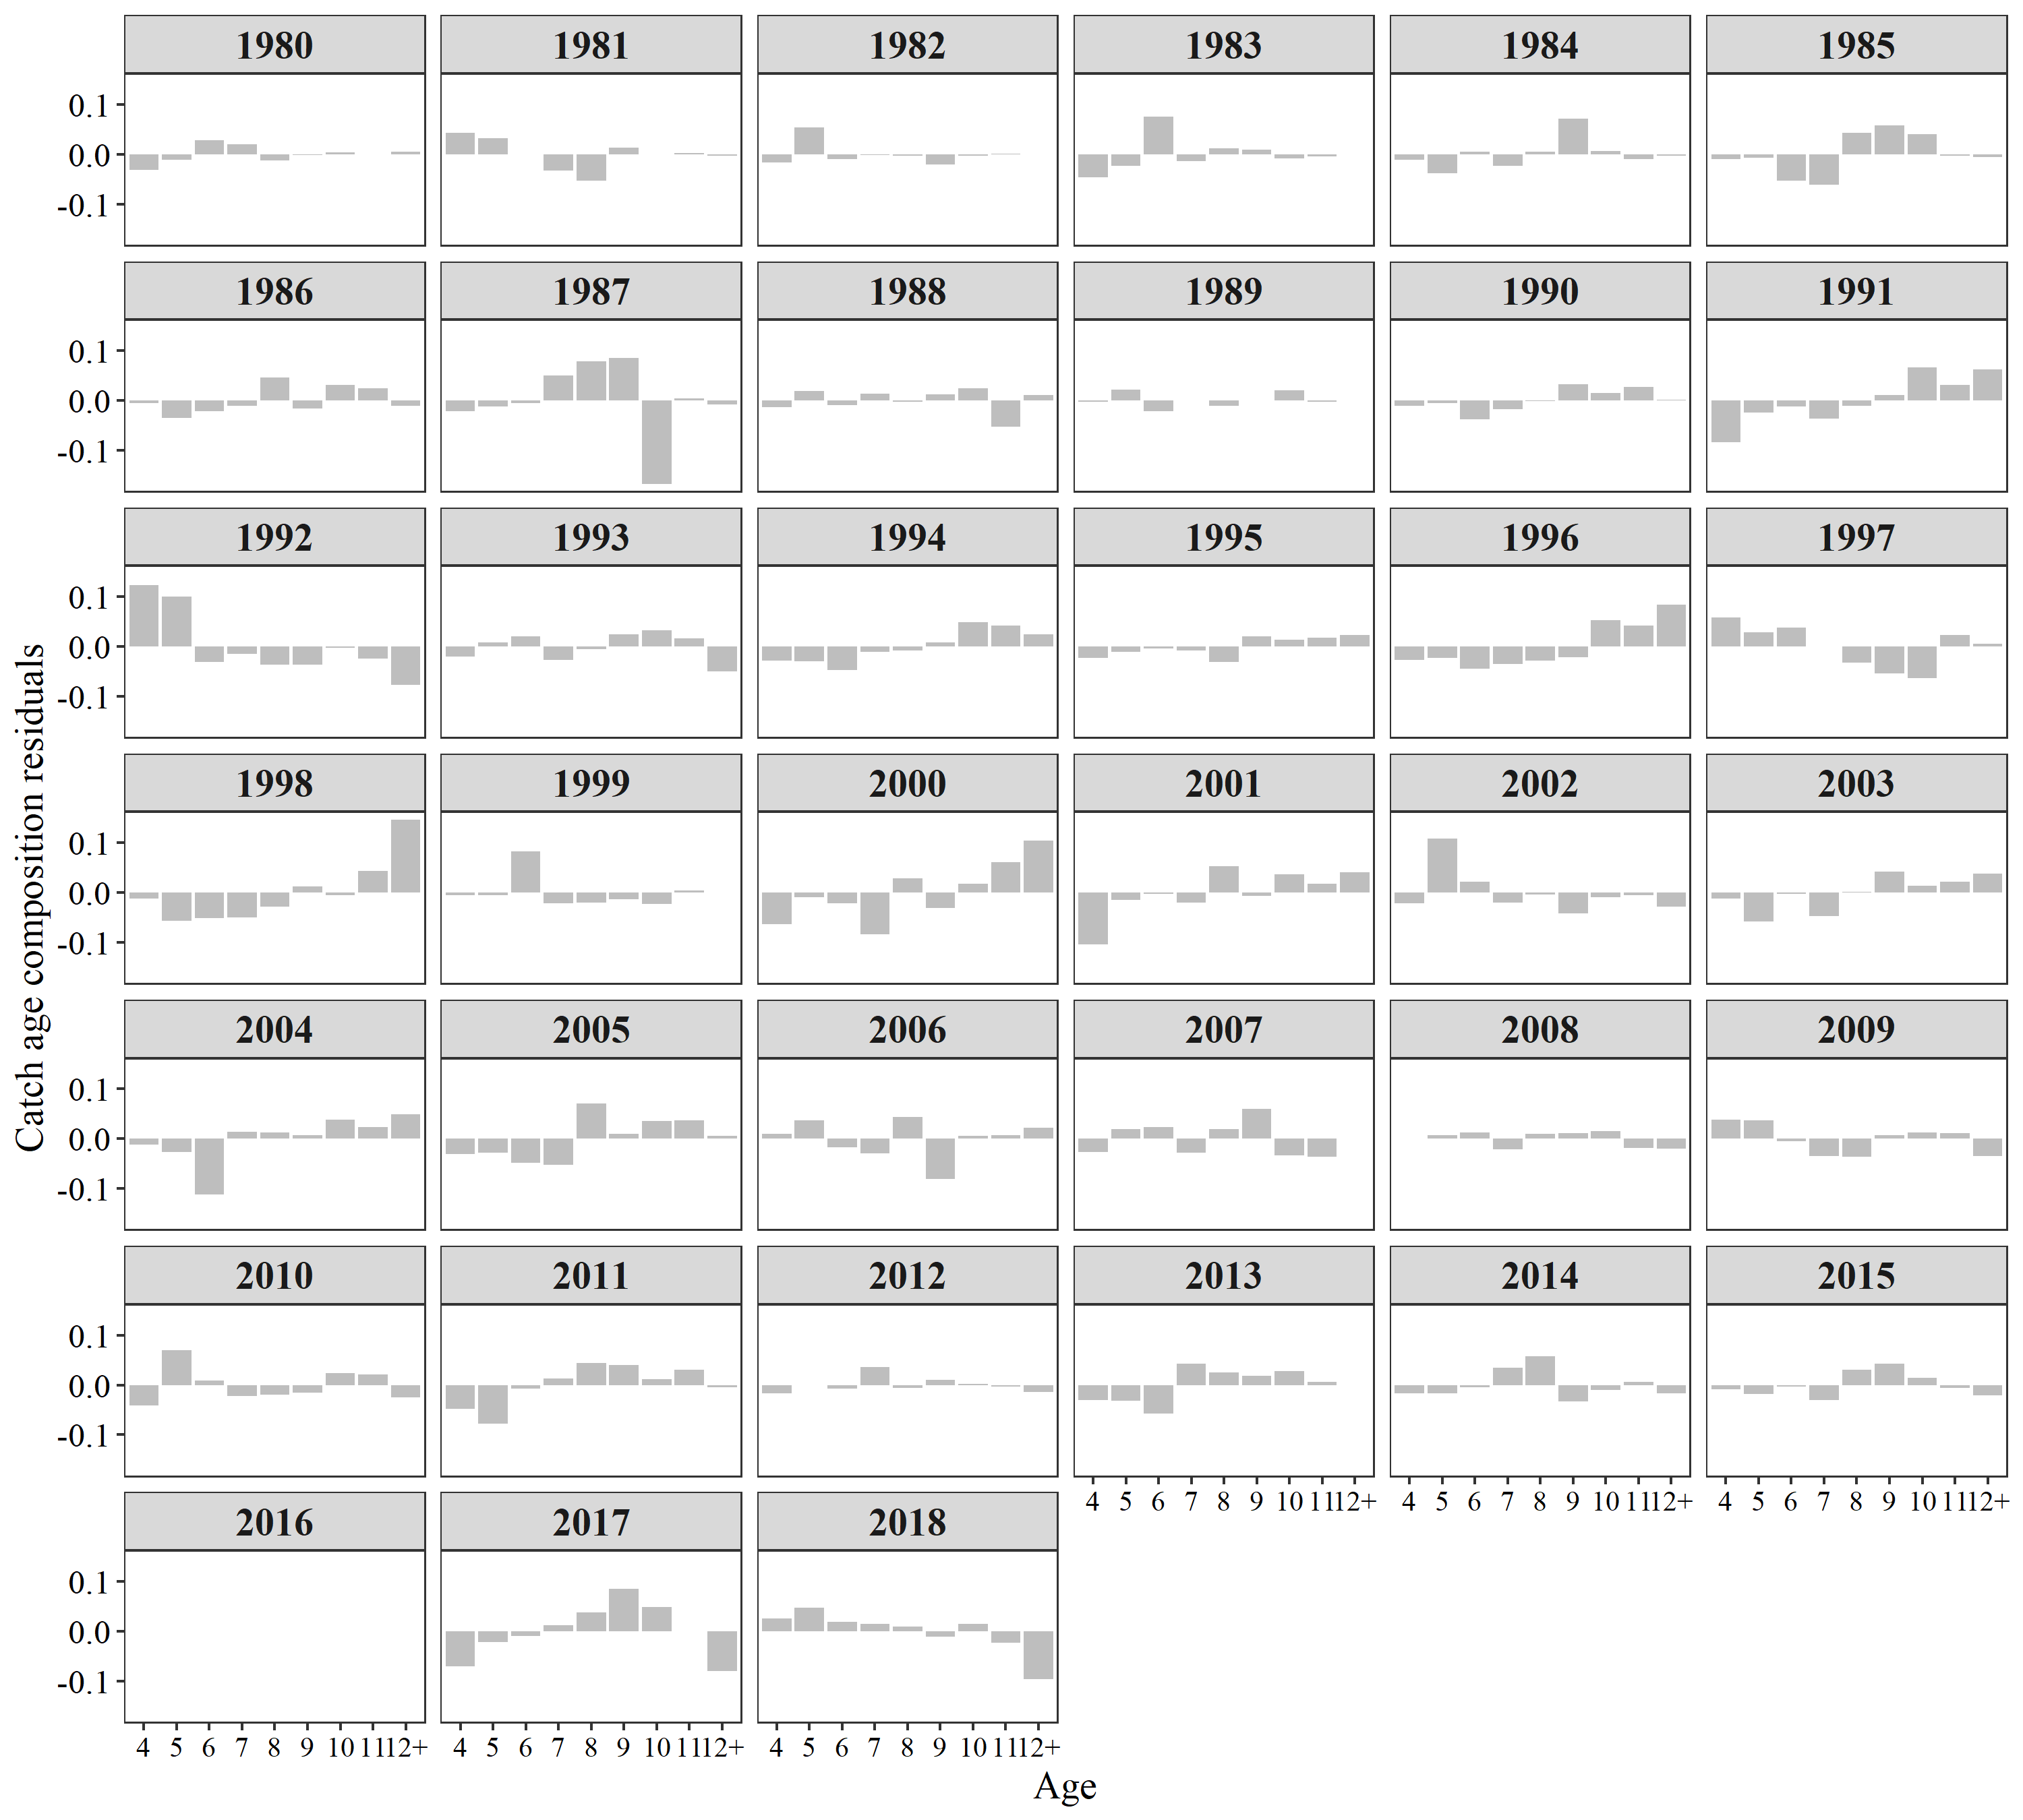

**Figure 19:** Residuals from model fits to commercial purse seine age compositions.